Air Force Junior ROTC

TX – 952
Corsicana, Texas

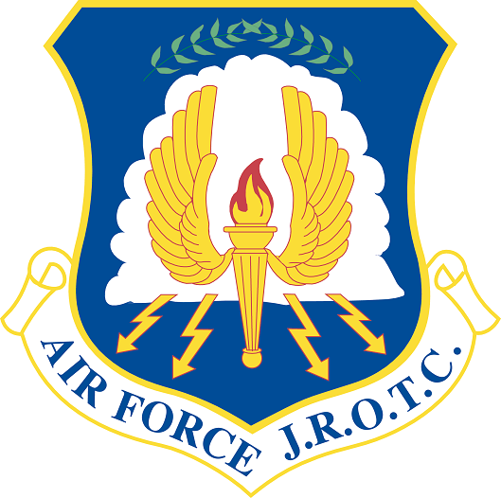
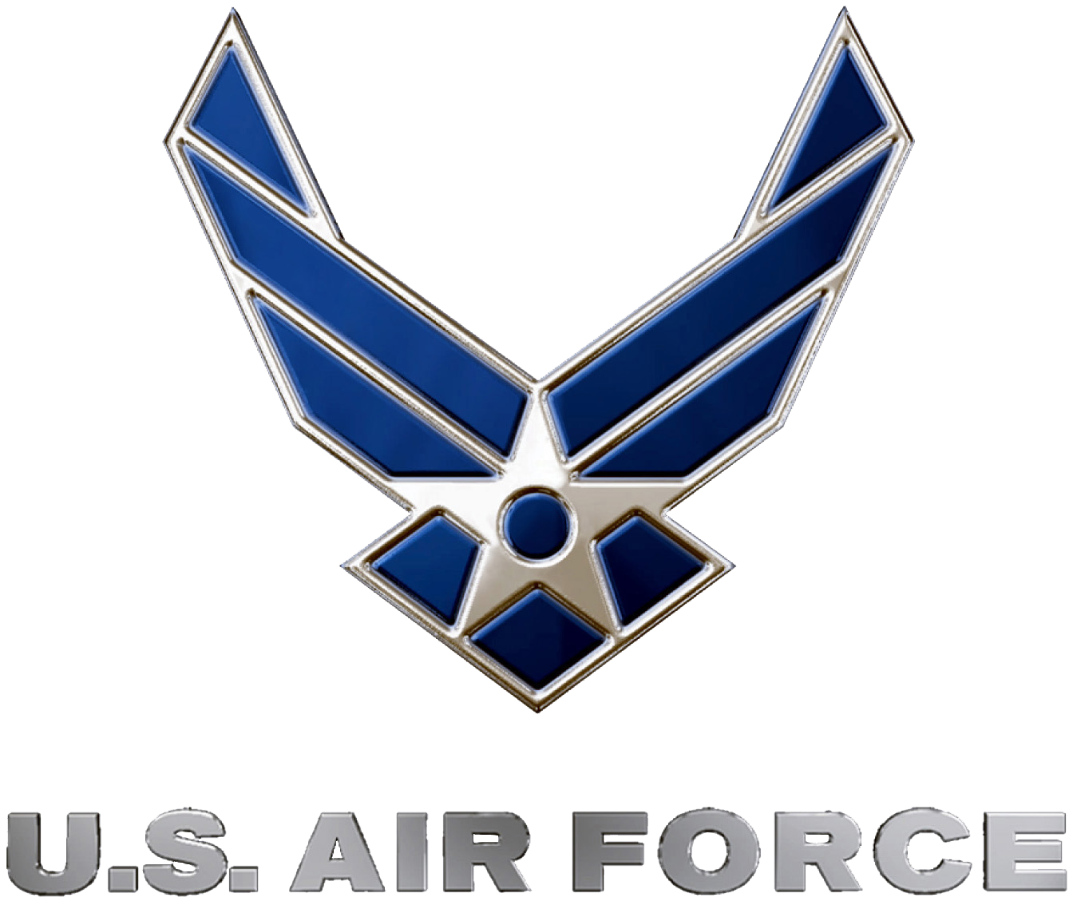



Cadet Handbook
“TX-952, Best in Blue”

Name __________________________ Flight ________

2019-2020
This handbook is dedicated to the men and women that have served and are currently serving our nation both stateside and overseas.

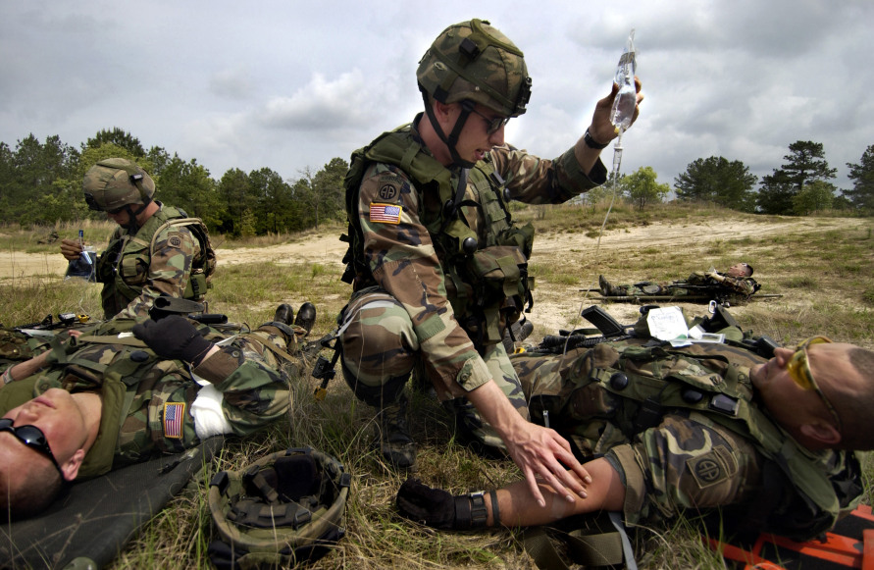

The fact is, millions have died securing our freedoms starting with the Revolutionary War to the current war on terror. Too often we take these freedoms for granted and act like we don’t have to do anything for them. As the late President Ronald Reagan said:

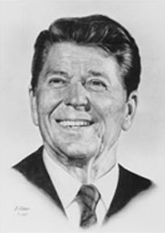

“Freedom is never more than one generation away from extinction. We didn't pass it to our children in the bloodstream. It must be fought for, protected, and handed on for them to do the same, or one day we will spend our sunset years telling our children and our children's children what it was once like in the United States where men were free.”

You are in a class where you will have the privilege to wear the same uniform that the active duty Air Force members wear. There are those you will “rub” shoulders with as you pass in the school’s hallways that will make light of the uniform. Don’t let their disrespect for themselves and our country impede, slow you down, from doing what is right and expected. Be proud to wear the uniform and wear it properly. It is a privilege and duty to wear the uniform while you are in AFJROTC. Welcome to a class that just might change your life.

THE AIR FORCE JUNIOR ROTC CADET CREED

I am an Air Force Junior ROTC Cadet.

I am connected and faithful to every Corps of Cadets who
serve their community and nation with patriotism.

I earn respect when I uphold the Core Values of Integrity First, Service Before Self, and Excellence in All We Do.

I will always conduct myself to bring credit to my family, school, Corps of Cadets, community, and to myself.

My character defines me. I will not lie, cheat, or steal.

I am accountable for my actions and deeds.

I will hold others accountable for their actions as well.

I will honor those I serve with, those who have gone before me, and those who will come after me.

I am a Patriot, a Leader, and a Wingman devoted to those I follow, serve, and lead.

I am an Air Force Junior ROTC Cadet.

UNITED STATES AIR FORCE JUNIOR ROTC
Corsicana High School
3701 West Highway 22
Corsicana, Texas 75110
(903) 874-8211
TX-952@afjrotc.com, mmackey@cisd.org, or rhardie@cisd.org

MEMORANDUM FOR Corps of Cadets at TX-952 21 August 2019

FROM: Senior Aerospace Science Instructor

SUBJECT: 2019/2020 Cadet Handbook

1. Welcome to the 2019-2020 School Year and another exciting year in Air Force Junior ROTC here at Corsicana High School. I want you to know that we are dedicated to providing an environment that will help you grow into a mature adult--mentally, physically, and morally. We will do this by focusing on our mission to “develop citizens of character dedicated to serving their nation and community.”

2. We will strive to help you reach your full potential by emphasizing the Air Force Core Values of “Integrity First, Service Before Self, and Excellence In All We Do,” and the AFJROTC Cadet Creed (found on the inside cover of this handbook). Following these guidelines will enable you to do the following:

- Develop Leadership abilities
- Wear their uniform proudly and properly
- Respect the chain of command with the proper use of proper customs and courtesies
- Become proficient in individual and flight drill
- Conduct yourself in a socially acceptable manner in all situations
- Perform assigned duties as required
- Apply yourself to learn the fundamentals of the Aerospace, Leadership and Wellness components
- Practice good study habits and time management and strive to pass all of your classes
- Gain an appreciation for and demonstrate the fundamentals of a healthy lifestyle

3. Lastly, I want you to remember that your instructors are always here for you. We may set the bar high in our expectations of you, but we promise to be fair and understanding in every situation. Our door is always open! Corsicana High School AFJROTC and the Corsicana Independent School District do not discriminate on the basis of race, color, national origin, sex, disability or age in its programs or activities.

4. Again, welcome to another exciting year for TX-952! Remember … “TX-952 –“Best In Blue!”

MONTE R. MACKEY, Lt Col, USAF (Ret)
Senior Aerospace Science Instructor
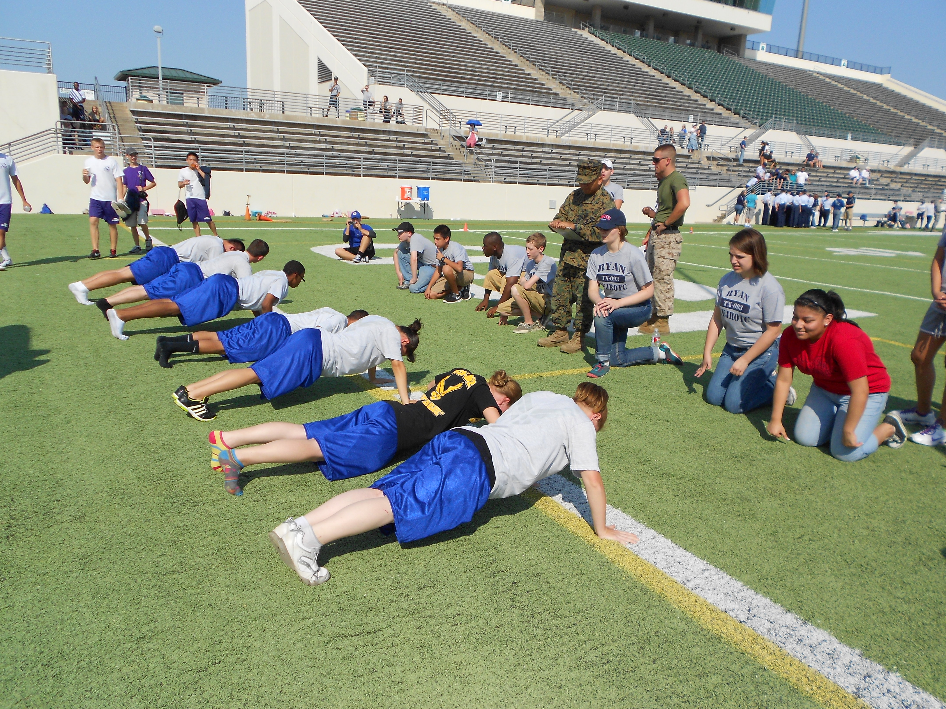

Each Class period will begin with role being called followed by the reciting of the Honor Code, the Air Force Core Values, Mission Statement, and the TX-952 Corps Values.

Table of Content
Page #’s
Enrollment/Disenrollment Policy | 7
Removal from AFJROTC, Escalation Process, Reserve Status | 8
Sample Failure to Meet Requirements Letter | 9
Uniform Wear Contract (Updated) | 10
Mission of AFJROTC | 11
Cadet Honor Code | 11
Air Force Core Values | 11
TX-952 Corps Values | 11
TX-952 Corps Sayings | 11
TX-952 Classroom Responsibilities and Procedures | 11-
Physical Discipline/Punishment and Hazing Polices | 12
Program Opportunities, Competitive Drill Teams, and LDR’s (Updated) | 12-14
AFJROTC Area | 14
Coming to AFJROTC during non-class times | 15
Cadet Uniform Wear Instructions | 15-17
Grooming standards to include the wear of Jewelry | 17-24
Uniform Inspection List | 25
How to wear ranks, name tags and ribbons | 26 27
Public Display of Affection (PDA) while in uniform | 27
Air Force and AFJROTC ranks and insignia and badges | 28-32
Uniform diagrams (Updated) | 33-46
AFJROTC Awards (Updated) | 47-63
Uniform shoulder cords | 48
Uniform Inspection | 64
Saluting others | 65
American Flag, Pledge of Allegiance, National Anthem | 65
Chain of command | 66
Warrior Knowledge | 66-67
Corps Organization and Staff Personnel Expectations (Updated) | 67-70
Military Drill (Marching) | 70-72
Parental Permission Slip for Trips (Updated) | 72
Promotion – How to get prompted and keep your rank | 73-77
Promotion, letter jacket, honor stole points | 77-78
The Tiger Order of the Sword | 79
Corps discipline system | 79-80
How to tie a tie | 81
Corsicana Independent School District Nondiscrimination Statement | 82

TX-952, “Best in Blue”
Enrollment/Disenrollment/Curriculum

ENROLLMENT: Enrollment is based on a student’s willingness to accept AFJROTC standards.

DISENROLLMENT: Disenrollment is based on a cadet’s failure to meet AFJROTC standards.
Because AFJROTC is an elective course, students join the program voluntarily. Voluntarily means you freely agree to abide by the standards of an Air Force JROTC cadet. According to AFJROTCI 36-2010, chapter 2, paragraph 2.4.1.1.3, a student may be removed from AFJROTC for failure to maintain standards including the wear of the Air Force uniform and grooming standards – the same as expected of an active duty Air Force member; indifference to training which includes classwork, physical training, and drill; and finally, disciplinary reasons. Therefore, if a cadet consistently fails to meet the requirements of the program, he/she may be removed from AFJROTC and transferred to another class – normally Physical Education. Usually this takes place at the end of the Fall Semester, but it can be at any time during the academic year. However, disenrollment is a last resort, taken only after the senior instructor has determined that leaving the program is the best thing for the individual and the Corps of Cadets.

CLASS SCHEDULES: Cadets attend classes five days a week. Classes are divided between academic instruction, leadership education, and physical training. Cadets are required to wear their uniform on Wednesday of each week. Each AFJROTC class period is designated as a “Flight.” Each class period names its flight commander with instructor concurrence. A total of eight flights make up the cadet corps, which is led by a Cadet Corps Commander selected each term by the instructors. The Cadet Corps Commander has a staff to assist him/her in running the corps. It should be emphasized that the Cadet Corps is run by and for the cadets under the guidance of the instructors. The Cadet Corps and the AFJROTC program will be what you and your fellow cadets make of it!

GRADING: Each cadet actually receives three grades in AFJROTC, one for academic instruction, one for leadership education, and one for physical training. In determining the overall grade for each grading period, the grading categories are weighted as follows: Uniform Inspection 40%; Test 30%; Physical Conditioning 20%; and Quiz-Class-Home-Work 10%.

Leadership Education Grades: Leadership education grades are determined by uniform wear/inspections, grooming standards, drill/ceremony, leadership class exercises, physical conditioning, and individual classroom conduct.

Academic Grades: Academic grades are determined by tests/quizzes, written assignments, oral presentations, class/group participation, workbook exercises, and individual classroom conduct/work.

Physical Training Grades: Physical training grades are determined by participation/effort/attitude in weekly physical training which is conducted on Friday of each week unless otherwise directed by instructors.

TEXTBOOKS: The textbooks used in the AFJROTC program are furnished to cadets without charge. All textbooks and leadership manuals are controlled items and must be safeguarded and accounted for. Cadets who damage or lose a textbook will be required to reimburse the Air Force for that book.
Three (3) failures to wear the uniform or maintain grooming standards in a nine week grading period will result in disenrollment. Disenrollment can occur any time during a semester. Disenrollment may result in loosing academic credit for the semester. Disenrollment will result in being removed from AFJROTC and moved into a different class. The cadet has the opportunity to make up the uniform wear up to four school days from the date the cadet failed to wear the uniform. Make up time will be adjusted for excused absences.

Removal Escalation Process

Student fails to wear uniform on uniform day (Wednesdays – first occurrence)
Notify parents
Uniform wear not made up by 4th school day (Tuesday the following week)
Referral to administration (include parent contact date)
Student fails to wear uniform on uniform day (second occurrence)
Notify parents
Uniform wear not made up by 4th school day (Tuesday the following week)
Referral to administration (include parent contact date)
Student fails to wear uniform on uniform day (third occurrence)
Notify parents
Uniform wear not made up by 4th school day (Tuesday the following week)
SASI notifies administrator and counselor to remove student from program
(See page 9 for sample letter to meet standards.)

Reserve Status

Reserve status allows a cadet who has completed at least one full year of AFJROTC in class to still participate in AFJROTC. What must one do to be a reserve cadet? Here’s the criteria:

- Must wear the cadet uniform on Wednesday
- Must stay in grooming standards
- Stay out of trouble – no discipline actions (ISS, OSS, ETC.)

Being a reserve cadet will allow you to be on drill teams, go on field trips, and do community service. This will be tracked in Wings but will not count toward the certificate of completion. The certificate of completion is only presented to those cadets who have completed at least three years in AFJROTC in the actual class.

Sample Failure to Meet Requirements Letter

MEMORANDUM FOR THE PARENTS/GUARDIANS OF __________________________________

FROM: AFJROTC TX-952

SUBJECT: Failure to Maintain Standards or Meet Requirements

1. Cadets enrolled in the Air Force Junior ROTC Program are required by the Contractual Agreement between Corsicana High School and the United States Air Force, applicable service directives, and the TX-952 Cadet Handbook to meet the standards as described in the following paragraphs.

2. Cadet ______________________________ has failed to meet the standards indicated below and may be disenrolled from the course if actions are not immediately taken to remedy failure.

a. _____ Failure to maintain acceptable standards.
b. _____ Inaptitude or indifference to training.
c. _____ Disciplinary reasons.
d. _____ Failure to remain enrolled in school.
e. _____ Other reason: ____________________________________.

3. Cadet ________________________________ has failed to wear the uniform _____ times this semester on the dates of ___________________________________. If he/she does not make these up in accordance with our published grading policy, he/she will be disenrolled from AFJROTC.

4. If you would like to contact us in this matter, please give me or MSgt Hardie a call during school hours at (903) 874-8211.

MONTE R. MACKEY, Lt Col, USAF (Ret)
Senior Aerospace Science Instructor

AFJROTC UNIFORM WEAR POLICY/CONTRACT

(This contract is to be taken seriously. One of the things we teach in AFJROTC is being responsible. Without a doubt, at some point in time each student that enrolls in AFJROTC will sign a contract to purchase something or provide or receive a service of some sort. Surely every parent/guardian who signs this contract has already experienced the importance of a contract and abiding by the contract. For our part, the instructors will make sure each student is issued/loaned a uniform at no expense to the student or parent/guardian. We will insure alterations are made if necessary at no expense to the student or parent/guardian. For the part of the student and their parent/guardian, they must wear the uniform properly the one day a week it is expected to be worn. The uniform must be kept cleaned and stored properly when not being worn. Lastly, the uniform must be returned when the student leaves AFJROTC or when directed by the instructors.)

1. Uniform wear day is Wednesday and the maximum inspection grade is 100 points.

2. If the cadet fails to wear the uniform or meet grooming standards three (3) times in a nine week grading period, he/she will be disenrolled from AFJROTC. This may result in not receiving academic credit. It will result in being removed from AFJROTC and moved into a different class – probably Physical Education.

3. If a cadet has an excused absence on Wednesday and/or the following days, the uniform wear/inspection grade will be made up on the next attendance day. Uniform makeups must be done within 4 school days – the following Tuesday. Make up time will be adjusted for excused absences.

4. To receive credit for uniform wear, a cadet must wear the uniform all day to all classes. That is, a full day for a full grade. The uniform can, of course, be removed for physical education and other classes that require special attire. But, the uniform must be put back on after that class.

5. It is the cadet’s responsibility to ensure he/she complies with uniform wear requirements.

CADET’S NAME (PRINT)______________________________________

CADET’S SIGNATURE___________________________________

Date____________________

PARENT’S/GUARDIAN’S Name (Print)__________________________________

PARENT’S/GUARDIAN’S SIGNATURE ________________________________

Date: ______________________

Parent’s/Guardian’s Phone number: _____________________________________

Parent’s/Guardian’s email address: ______________________________________

Mission of Junior ROTC:

Develop citizens of character dedicated to serving their nation and community.

Cadet Honor Code

“We will not lie, steal or cheat, nor tolerate among us anyone who does.”

Air Force Core Values

Integrity First - being honest; doing what you say you’ll do; doing what’s
right when no one is looking.

Service Before Self - putting needs of the Corps and your school before yourself.

Excellence in All We Do - doing the best job you can, not just the minimum; always
striving to improve.

TX-952’s Corps Values

Respect - treating others, and ourselves, with respect due all people because
of their inherent worth as human beings.

Responsibility - doing what you’re supposed to do; doing what’s right regardless
of what others do; doing your job without being forced or
watched; being responsible for your own actions

Followership/Leadership - followership: submitting to and obeying orders of those above
you; cooperating with leaders; taking care of your own
responsibilities before becoming responsible for others.
- leadership: setting a good example, using authority properly; trying to serve those under you rather than being served

Unity - working together for a common purpose; being a team builder and not fighting or arguing

Patriotism - appreciating the good things about America – its values,
freedoms and opportunities, and the price paid by others to
preserve these things

TX-952’s Sayings

Our motto: “952, Best in Blue.”

“We think the best, we believe the best and we speak the best about other cadets.”
“If it were easy, everybody could do it, and then it wouldn’t mean very much.”

TX-952 Classroom Responsibilities and Procedures

- Be on time and come prepared – paper, pencils, pens, etc
- Throw away or put away gum, food and drinks before entering the classroom. (Unless authorized by the SASI or ASI.)
- Put book bags under the table.
- Begin each class with: “Flight, attention, parade rest”, elements leader report.
- Be polite and respectful.
- Don’t talk without permission. Raise your hand and get permission.
- Help each other.
- No put-downs.
- Stay awake – keep head up; stand up if you have to.
- Stay in your seat unless told or given permission to leave it.
- Walk behind the tables, not between the instructor and the class.
- End each class with: “Flight, attention, dismissed.”

Physical Discipline/Punishment and Hazing

Physical Punishment: The instructors nor any cadet can give physical punishment to a cadet. Period!! Punishment such as push-ups, sit-ups, standing at attention for a prolong period of time, etc. Push-ups, sit-ups, and running are for physical training only and will be done on physical training days – never to punish a cadet.

Hazing: “To persecute or harass with meaningless, difficult, or humiliating tasks”. Hazing will not be tolerated here at Corsicana High School. It is not allowed in the military academies and will not be allowed in this AFJROTC program. Anyone caught hazing or tolerating another cadet being hazed could result in the guilty parties being removed from AFJROTC. You are guaranteed some form of disciplinary action.

Program Opportunities

AFJROTC is more than a class. Most of what we do occurs after school and on weekends. These are called extra-curricular activities. They are classified as “Competitive Drill Teams”, “Community Services”, “Curriculum in Action trips”, and “Co-curricular” activities. We will start with competitive drill teams.

Junior ROTC Competitive Drill Teams
JROTC units compete against other units in many types of drill and also physical training (PT). Teams consist of 9 to 12 cadets, plus their commander. In PT, 4 male and 4 female cadets compete. At some meets individuals and pairs may compete in Demil exhibition. The types of teams are:

Requirements to be on a team: Show up for the practices consistently unless you are out sick or there has been a family emergency. If you can’t make practice, tell the commander of the team. You must give 100% effort. No playing around – time is short. It is preferred that you dedicate your time to the team and not be split between multiple school activities – this never works out.

Unarmed – Marching without a rifle.
- Regulation – Completing a sequence of approximately 50 standard movements. All movements must be performed according to military drill regulations.
- First Year Regulation – Regulation for teams made up of only first-year cadets.

Armed: Demil rifle or saber – Marching with a rifle or saber. Demil is short for “demilitarized”. The rifle we use is a replica of a real M1903 WW I and II Springfield rifle and weighs 8.4 pounds. The sabers we use are Marine Corps replicas.
- Regulation – Completing a sequence of standard marching and rifle/saber movements. All movements must be performed according to military drill and rifle/saber regulations.

Color Guard – Performing a standard series of movements with the US and Texas flags. It includes movements that normally are not performed at an actual color guard event.
- Male – all male team.
- Female – all female team.
- Mixed – any combination of male and female.
At most drill meets, only 2 of these teams compete, usually Male and Female or Mixed.

Inspection – Cadets are inspected for uniforms and military-related knowledge. Their uniforms are inspected very carefully, so they must be almost perfect. Usually they’re asked “Warrior Knowledge” questions about such subjects as the Air Force, the US flag, first aid, and chain of command.

PT – Separate male and female teams compete in 4 exercises: push-ups, sit-ups, standing broad jump, and a sprint of about 100 yards.

Support Team – This is a group of cadets who do not practice or compete, but go to meets to help the competition teams get ready. These cadets must be trained, and go to at least 3 drill meets. They earn a Drill Team ribbon for their work.

Our annual Tiger Invitational drill meet.

You run the drill meet. Cadets from other schools come here to compete against each other. You do not compete – you make the competition happen. It is a long day but a great leadership experience.
Community Services

As the mission statement says, “Dedicated to serving their nation and community”. We do some things that are strictly community service while others are Leadership Development Requirements, LDR, with community service hours. The following will list Leadership Development Requirements and community services.

Note: With more rank comes more responsibilities and that includes actively participating in community services and at least one or more LDR activities

All cadets are expected to earn 50 community service points and one LDR activity per semester.

Leadership Development Requirements with/without community service hours. Here are examples:
- - - Drone/Multicopter Team (With and Without) (STEM Based)
- --- Learn to fly the Air Force provided Drone/quadcopter
- - - Flight Simulator Team (Without) (STEM Based)
- --- Must learn be trained using the flight simulator in order to fly any of the RC aircraft in JROTC. On this team you are taught by a fellow cadet how to use the simulator flying different aircraft within the training program.
- - - Home football games march-on. (With) (Unit Based)
- --- What a great opportunity to earn letter jacket points as well as community service hours by marching on to the football field during the playing of the National Anthem. On top of that, you get into the game for free and promote AFJROTC to a large crowd.
- - - Local color guard presentations. (With) (Activity Based)
- --- This is beyond our competition color guards. We are asked multiple times thought out the year to come and present the nation’s colors. These normally happen during the school day. You earn letter jacket points for being on this team for each presentation of the colors.
- -- Recruiting Team(Without) (Unit Based)
- --- One of the important responsibilities of each cadet is to promote AFJROTC to your fellow students. This team however actually actively does this by visiting the middle school several times during the school year and here at the high school.
- - - Push-Up Squad Team (With) (Unit Based)
- --- The push-up squad goes to each home football game and does push-ups for each touchdown the home team scores. You must try out for this team and be able to do at least 30 push-ups to qualify. If you make the team, you get to wear the Airman Battle Uniform, ABU’s. You also earn letter jacket points each game.
- - - Adopt a Highway Team (With) (Unit Based)
- --- Four times a school year we go out and pick-up the litter on our portion of highway 22. This is a community service and it earns letter jacket points.
- - - Morning Flag Team (With) (Unit Based)
- - - Paintball battles or ropes courses (Without) (Activity Based)
- --- In an effort to keep all cadets excited about being in AFJROTC, we try our best to go to a ropes course or to do a paintball battle. Both of these are fun and gives you a chance to build relationships with your fellow cadets.
- - - Bataan Death March Memorial Hike (Without) (Activity Based)
- --- In honor of those who died and those who survived during this horrible march, we do a 14-mile hike each November prior to Veteran’s Day. This hike gives each cadet a chance to get sponsors for the rising money given to the Angels of Corsicana Troop Support, a local organization that packs and ships care-packages overseas to active duty personnel serving in some pretty-dangerous locations.
- - - Salvation Army Bell ringing Team (With) (Unit Based)
- --- Starting in November and going through to the last Saturday prior to Christmas, you get the chance of standing out in front of Walmart ringing the Salvation Armies’ bells. This is a tremendous community service that helps raise funds that are used here in Corsicana to help the least fortunate.

- - - Military Ball Planning Committee (Without) (Unit Based)
- --- Each year a group of cadets get together to decide what the theme of the Military Ball will be. They also plan on decorations and food for the evening. They are responsible in getting an estimate of what the evening will cost. Anyone is welcome to help with the committee.
- - - Model Rocketry Planning Committee (Without) (STEM Based)
- --- Normally after the last drill competition for the school year, the model rocketry class is held. The class is held after school for approximately two weeks. The class is taught by cadets who have passed the class in previous school years. You will learn about the history of rockets, Newton’s laws of motion, and some of the physics involved in rocketry.
- - - AFJROTC Orientation Class (Without) (Unit Based)
- --- Each year in August prior to school starting, in-coming 9th graders are invited to this four-day class. The class prepares them to help lead their first year class period. You can earn your first promotion by attending this class. The orientation class is taught by 2nd through 4th year cadets.
- - - Fish Camp Detail (With) (Unit Based)
- --- This is school-based service to help the in-coming 9th graders learn where to find their classrooms as well as experience their first pep rally. Cadets help out by passing out class schedules and proving the color guard for the pep rally.
- - - Cadet Leadership Course(Without) (Unit Based)
- --- Normally the first week in June this course is held It consist of five-days of class where those cadets between their first year and second year receive additional training. The purpose is to train them to take on more leadership roles within the corps.
- - - Cadet Staff Leadership Course (Without) (Activity Based)
- --- This more of a college level of training held at Howard Payne University in Brownwood, Texas. You actually get to live on campus in a college dormitory and eat in the college dinning facility. To get to meet cadets from other units in the state of Texas. You learn from other instructors and you learn from other cadets.
- - - Cadet Training Officer (With) (Unit Based)
- --- This is a leadership position where you have already gone through CLC, CSLC, or both. You train for the week. This takes a week of your summer vacation and is seen as a community service.

Community Service Only:

- - - Walk-A-Thon
- --- This is held at the same time as the Bataan Memorial Death March hike. You get sponsors to donate toward the miles you hike. The donations go to the Angels of Corsicana Troop Support.
- - - Flag placement on Veterans Day
- --- Prior to Veteran’s Day, we go out to one of the local cemeteries to place flags at veterans graves. We does this in conjunction with the local Vietnam Veterans of America Association. After Veteran’s Day, we go back to retrieve the flags.
- - - Visits to nursing homes

- - - North and East Texas Food Bank Team
- --- We go to the food banks to help sort, pack, and palletize thousands of pounds of food to help those in North Texas, which includes Corsicana, and those in East Texas. It is a fun day working along side of your fellow cadets. It is a feel-good experience.

Curriculum in Action Trips
Curriculum in action trips are field trips associated with the curriculum being taught. Each year we take a trip to the Frontiers of Flight Museum at Love Field in Dallas. This is a great experience in the History of Flight which goes along with the Aerospace Science subject of “Milestones in Aviation History”, “Science of Flight”, and “Exploration of Space”. We normally take a special trip during February where we hopefully get to ride on a charter bus to places like NASA in Houston; Barksdale Air Force Base, Louisiana; or the National Museum of the Pacific in Fredericksburg, Texas. You must be passing to go on any of these trips.

AFJROTC Area

- Instructor’ Offices
  - Do not enter without permission. Knock first.
- Logistics and Storage rooms
  - Do not go into them without a need to.
  - Do not go past the Logistics counter without permission.

- Cadet Office (Flight Simulator Room)
  - This is reserved for cadets training using the flight simulator.
- Drill and Break Area
  - Keep it clean.
  - No horse-playing or running. No horse play is not just a school policy but one of the Air Force’s.

Coming to the AFJROTC Area During non-Class Times

Before school starts: Cadets are allowed to come to the AFJROTC area before the first period starts, but only if: they have a AFJROTC ID or a signed AFJROTC pass, and a AFJROTC instructor is present. Also, once here, cadets MUST remain in the AFJROTC area until the bell rings for first period to start.

To prepare for an event: If a cadet must prepare for a AFJROTC event, such as a color guard, during the school day, he/she may be able to leave his/her other class to come to the JROTC area. To do this a cadet must obtain permission beforehand from a AFJROTC instructor and his/her teacher.

Other times: Only with permission from the AFJROTC instructors. You are expected to stay in your classes even if the teacher is willing to let you go. This creates problems for the instructors and other school staff. No one is allowed to come to AFJROTC during their lunch – period. We have a class during that time and need the same teaching atmosphere you have when you come to AFJROTC for class. We do not have a janitorial staff in here during lunch times therefore you are not allowed to come here with or without food!

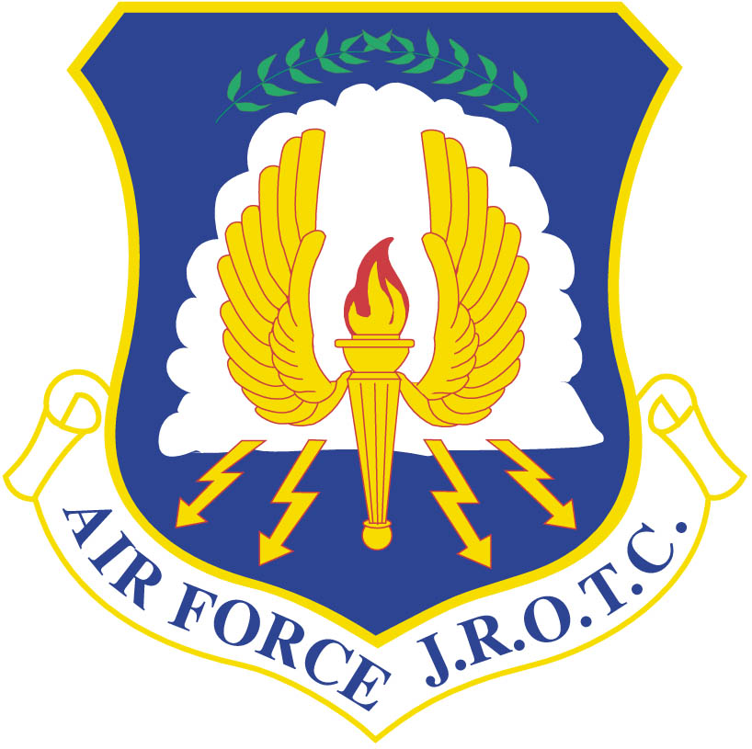

Air Force JROTC Cadet Uniform Wear Instructions

Introduction. The uniform that will be issued to you is a real Air Force Uniform. It is to be worn with pride keeping in mind those serving on active duty putting their lives on the line for your freedoms. Wearing the Air Force uniform is an important part of Junior ROTC. Your uniform grade accounts for 40% of your overall grade. During each uniform inspection, you will start with 100 points. If you fail to wear the uniform on the scheduled uniform inspection day, you will start with 70 points as a make-up grade. I don’t know about you, but if I had a choice of 100 points versus 70, I would take the 100 points any day.

Here are some things you need to know about the uniform:
- It is a real Air Force uniform; the only difference is the rank insignia and patches.
- You will wear it according to AF regulations.
- It is loaned to you. You must return it (except for the shoes) when you leave AFJROTC.
- It is a privilege to wear this uniform. It represents something very important. Wear it properly and proudly. Your only cost is keeping it clean – a must!

When to Wear the Uniform:
- All cadets who are issued a uniform must wear it and be inspected in it once a week.
- Unless you wear the uniform for another activity or event, you MUST wear the uniform on “uniform day”, which is Wednesday. For First semester only!!!! All cadets are expected to attend the five home football games. (Unless you are in the school band, cheerleading, dance team, or the football team.) This will be your uniform inspection for the week. There are five benefits to coming to the games and wearing the uniform. They are:

- You get an automatic100 uniform grade
- You get into the game for free (We do a march on to the football field prior to the National Anthem.) Just think, you looking sharp in front of the home team crowd.
- You earn letter jacket points
- You earn community service hours
- You wear the uniform for less time for the game versus the whole school day; however, you must wear it the whole game. Anyone caught changing out of the uniform will receive a uniform grade of zero for the week versus the 100.

- On uniform day, you must wear the uniform the entire school day for a full grade, except for PE or athletics periods, or classes or activities which are likely to get the uniform dirty, such as auto tech. Change out of the uniform for that class period only. Here’s the logic for the whole day for a whole grade. No employer in their right mind would pay you for eight hours of work when you only worked one or two hours. So don’t expect your instructors to give you a whole grade when you did not wear the uniform the whole day.
- If absent on the uniform inspection day, you MUST wear the uniform the next day back at school. This will count as a full grade. If not worn the following day of your absence, the grade starts at 70% and could go as low as 50% – it is your choice and your grade. If not worn the week of the uniform inspection, you have until the following Tuesday to make it up. The ONLY exceptions are serious illnesses or family emergencies beyond your control keeping you out during the day of the inspection and those days following the inspection day.
- As stated above, you also must wear the uniform when the AFJROTC activity requires it.
- You MAY NOT wear the uniform:
  - When playing sports or involved in any activity that might soil or damage it.
  - To protests or demonstrations or any other activity that the Air Force should not be associated with including political rallies. If in question, ask one of your instructors.

Cleaning Suggestions:

The ideal way of cleaning the dark blue portions of the uniform is by having them dry cleaned. Both the button up service coat and the zip-up jacket and pants MUST be dry cleaned, NO exceptions, to prevent damaging the items.

Now, to help save time and money, there is one item that can be cleaned at home as long as the following instructions are followed:

- The Uniform shirt: This shirt may be washed at home with like colored items. It must be washed once a week if the shirt was worn. It is suggested that the shirt collar be pre-treated with a stain remover if available. It must be washed. The uniform shirt will become stained around the collar and the arm pit area if the shirt is not washed properly.

Basic Guidelines for Wearing the Uniform and grooming standards are in accordance with Air Force Instruction 36-2903, Dress and Appearance:
- Wear a complete uniform. (pants, shirt with V-neck T-Shirt underneath, belt, shoes, socks, coat or jacket if necessary, and hat if outdoors) Do not wear just part of it.
- Don’t combine with civilian clothing items, except a coat if needed for cold weather.
- Shirt/blouse:
  - You may wear it with or without the tie/tab.
  - Do not button the top button unless you wear a tie/tab.
  - Wear a white, V-neck T-shirt. No other color is authorized.
- Tie/tie tab:
  - You may wear the tie/tab whenever you wish.
  - You must wear a tie/tab with the Service Dress Coat.
  - You do not have to wear a tie/tab with the Light-Weight Jacket.
- Light-Weight (zipper) Jacket:
  - It must be zipped, with the zipper no lower then half way between the collar and waistband.
- Service Dress Coat:
  - The Service Dress Coat is rarely required for weekly uniform inspections, but you may wear it anytime you wish.
  - If you wear the Service Dress Coat, you must wear the tie/tie tab.
Grooming Standards (when in uniform)
Hair-male and female. Will be clean, well-groomed, present a professional
appearance, allow proper wear of headgear. Will NOT contain excessive amounts of grooming aids (e.g. gel, mousse, pomade, moisturizer), appear lopsided, touch either eyebrow, or end below an imaginary line across the forehead at the top of the eyebrows that is parallel to the ground. If applied, dyes, tints, bleaches and frostings must result in natural, human hair colors. The hair color must complement the member‘s complexion and skin tone. Examples of natural human hair colors are Black, Brown, Blond, Red, Auburn, Gray and White. Prohibited examples (not all inclusive) are burgundy, blue, purple, green, orange, and fluorescent or neon colors. . If a human can’t be born with it, then it is not allowed.

Jewelry (when in uniform)

Jewelry. Jewelry will be plain and conservative (moderate, being within reasonable
limits; not excessive or extreme) as determined by the local commander.

Earrings. Male cadets are not authorized to wear earrings on a military
installation, or while in uniform. Female cadets may wear small (not exceeding 6 mm in diameter) spherical, conservative (moderate, being within reasonable limits; not excessive or extreme) round white diamond, gold, white pearl, or silver earrings as a set with any uniform combination. If a female member has multiple holes, only one set of earrings are authorized to be worn in uniform and will be worn in the lower earlobes. Earrings will match and fit tightly without extending below the earlobe unless the piece extending is the connecting band on clip earrings. (NO DESIGNS OF ANY KIND ON EARRINGS.)

Bracelets. Ankle bracelets are not authorized. Cadets may wear one bracelet
around their wrist. If worn, the bracelet will be conservative (moderate, being within
reasonable limits; not excessive or extreme) (which is defined as plain, not drawing
attention or faddish) in design, no wider than ½ inch, gold or silver in color, and will not
have any inappropriate pictures or writing. Medical alert/identification bracelets are
authorized; however, if worn, they will be conservative (moderate, being within
reasonable limits; not excessive or extreme) (which is defined as plain, not drawing
inappropriate attention or faddish). Bracelets espousing support for causes, philosophy, individual or groups are not authorized (Exception: Traditional metal POW/MIA/KIA bracelets, which come in colors besides silver, bronze, or gold, remain authorized).

Watches. Must be conservative and only one can be worn around the wrist while
in uniform, physical training gear, PTG, or civilian attire in an official capacity. Conservative examples (not all inclusive) are solid color black, brown, silver or gold. Prohibited examples are diamond covered, no studs, neon, bright colors, and bands that exceed 1-inch width.

Rings. Cadets may wear a total of three rings - period. That means one on one hand and two on the other or all three on one hand. Rings will be worn at the base of the finger, and will not be worn on the thumb.

Necklaces. Will not be visible at any time. If worn, will be concealed under a collar, if top button is buttoned, or concealed by an undershirt.

- Fingernails and cosmetics:

Fingernails. Male Airmen are not authorized to wear nail polish. If worn by females, nail polish will be a single color that does not distinctly contrast with the female Airman’s complexion, detract from the uniform, or be extreme colors. Some examples of extreme colors included, but are not limited to, purple, gold, blue, black, bright (fire engine) red and florescent colors. Do not apply designs to nails or apply two-tone or multi-tone colors; however, white-tip French manicures are authorized. Fingernails must not exceed ¼ inch in length beyond the tip of the finger and must be clean and well-groomed. Fingernails must not interfere with the performance of assigned duties. Cosmetics: Male Airmen are not authorized to wear cosmetics. Female Airmen may wear cosmetics; however, if worn, they will be conservative (moderate, being within reasonable limits; not excessive or extreme) and in good taste. Female Airmen will not wear shades of lipstick that distinctly contrast with their complexion, that detract from the uniform, or that are extreme colors. Some examples of extreme colors include but are not limited to, purple, gold, blue, black, bright (fire-engine) red, and fluorescent colors. Cosmetics will not be worn during field conditions – physical training.

(Below is a no, no. If you spend the money, oh well, you knew not to.) If you choose not to follow the rules, it’s an automatic 10 point deduction from your uniform grade. Ladies, please follow the rules. The instructors want you to look professional.


(These are too long and dirty looking!)

(French tips are authorized)
 ( These look extremely nice and professional.)

Hair Styles:
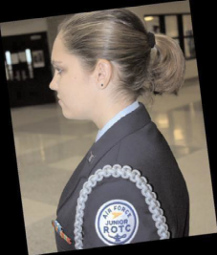 Female Cadet Grooming Guidelines: (See figures on page 21 for authorized and unauthorized styles.) Hair-Female. Minimum hair length is ¼ inch, to a maximum bulk of 3 ½ inches from scalp and allows proper wear of headgear. Hair will end above the bottom edge of collar and will not extend below an invisible line drawn parallel to the ground, both front to back and side to side. Bangs, or side-swiped hair will not touch either eyebrow, to include an invisible line drawn across eyebrows and parallel to the ground. When in doubt, assess correct length of hair with Airman standing in the position of attention

The intent is for pinned-up hair to be styled in a manner that prevents loose ends from extending upward on the head. For example, when using a clip or hairpins, hair will not present the appearance of a rooster tail. When hair is in a bun, the bun must be a single bun; no wider than the width of the head and all loose ends must be tucked in and secured. When hair is in a ponytail, it must be a single ponytail; that does not exceed bulk and length standards and does not extend below the bottom of the collar (except while in the PTG). As with all hairstyles, a neat and professional image is essential.

Hair accessories: If worn, BLACK hair accessories (fabric scrunchies, hairpins, combs, clips, headbands, elastic bands and barrettes, etc.) are authorized regardless of hair color. Headbands or fabric scrunchies will not exceed one-inch in width. Ornaments are not authorized (i.e., ribbons, beads, jeweled pins).

Braids, twists, micro-braids, French braids, Dutch braids and cornrows are authorized. A braid or twist is two or more portions of interwoven hair. If adding additional hair, it must be a natural looking color, similar to the individual's hair color. It must be conservative (moderate, being within reasonable limits; not excessive or extreme) and not present a faddish appearances. Hair must not exceed bulk and length standards and must not extend below the bottom of the collar Headgear must fit properly.

All braids/twists, when worn will be of uniform dimension, no wider than one inch, with natural spacing between the braids/twists and must be tightly interwoven to present a neat, professional and well-groomed appearance. When worn, multiple braids shall be of uniform dimension, small in diameter (approx. ¼ inches), show no more than ¼ inch of scalp between the braids and must be tightly interwoven to present a neat, professional appearance. A braid/ twist must continue to the end of the hair without design and following the contour of the head, and may be worn loose or in a secured style within hair standards in paragraph above. Exception: Micro-braids or twists are not required to continue to the end of the hair.

Unauthorized: Locs and shaved heads. Locs are defined as portions of hair that have been intentionally or unintentionally fused together to form a loc or locs. Shaved heads are defined as complete removal of all hair to the skin on the head or portions of the head. Hair color, highlights, lowlights, and frosting will not be faddish or extreme and will be natural looking hair color, similar to the individual’s hair color (e.g. Black, Brown, Blond, Auburn, Red, Gray and White).


These styles to the left are authorized.

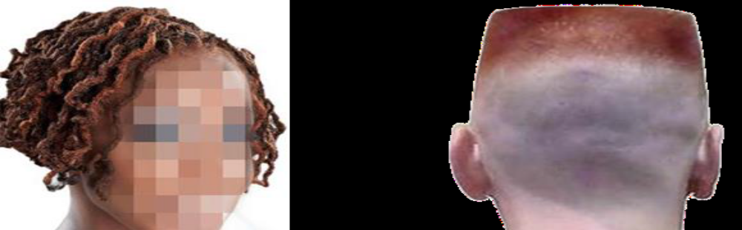
The styles to the left are not authorized.

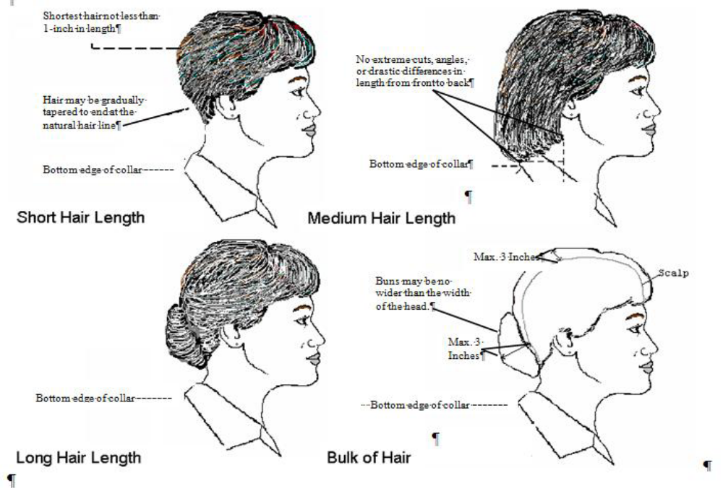
The drawings to the left are examples of authorized styles.
Specific Male Cadet Grooming Guidelines: (Refer to Figure on page 24.)
Hair. Keep your hair clean, neat, and trimmed. It must not contain large amounts of grooming aids such as greasy creams, oils, and sprays that remain visible in the hair. When your hair is groomed, it should not touch your ears or eyebrows, and only the closely cut or shaved hair on the back of your neck should touch the collar.

Your hair should not exceed 1 1⁄4 inch in bulk regardless of the length. Bulk is the distance that the hair projects from the scalp when groomed (as opposed to length of the hair). The bulk and length of your hair must not interfere with wearing any Air Force headgear properly, and it must not protrude below the front band of the headgear. Your hair must have a tapered appearance on both sides and back, both with and without headgear. A tapered appearance means that, when viewed from any angle, the outline of the hair on the side and back will generally match the shape of the skull, curving inward to the end point.

Your hair may not contain or have attached to it any visible foreign items. If you dye your hair, it should look natural. You may not dye your hair an unusual color or one that contrasts with your natural coloring. You may have sideburns if they are neatly trimmed and tapered in the same manner as your haircut. Sideburns must be straight and of even width (not flared) and end in a clean-shaven horizontal line. They may not extend below the lowest part of the outer ear opening. No extreme of faddish hair styles are allowed. Hair may not protrude below the front band of properly worn headgear.
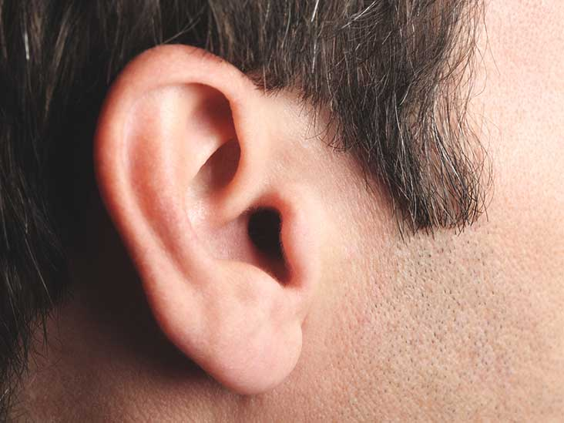

This is an example of sideburns that meet grooming standards. Notice where the lower opening of the ear is at. It is perfectly okay for the sideburns to be shorter.
Indicates stopping point for sideburns.
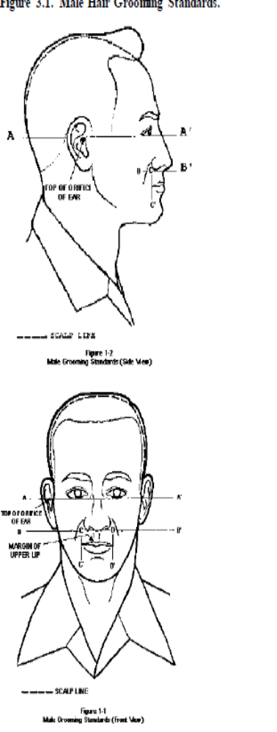


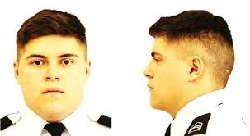

Inspected Items | Applies To | Points lost or Earned
Bearing | All Cadets | - 10 points
Wrinkled uniform | All Cadets | - 5 points
Dirty uniform | All Cadets | - 10 points
Name tag | All Cadets | - 5 points
Ribbons | If worn | - 3 points
Rank insignia | All Cadets | - 5 points
Shave | Males | - 10 points
Hair cut | Males | - 10 points
Hair length/Buns | Females | - 10 points
Hair accessories | Females | - 3 points
Socks | All Cadets | - 3 points
Badges - all | If worn | - 3 points
Gig-line | All Cadets | - 3 points
Belt | All Cadets | - 3 points
Earrings | Females | - 3 points
Dirty shoes | All Cadets | - 3 points
Rings | All Cadets | - 3 points
Stray strings | All Cadets | - 1 points
Fingernails polish and length | Females | - 10 points
Warrior Knowledge | All Cadets | + 3 points
Wrong T-Shirt worn under uniform shirt | All Cadets | - 5 Points

How to Wear Cadet Rank, the Name Tag and Ribbons

Rank Insignia:
- Shirt:
  - Cadet officers: wear “shoulder boards” that slide over the epilates of the shirt
  - Enlisted ranks:
    - Torch pointed toward point of the collar, centered between the bottom and top of the collar and side to side of collar. See examples on pages 29 and 34.
- Service Dress Coat
  - Grounded on (just barely touching) the lapel seam
  - Place half way up the seam
  - Parallel to ground
- Light Weight Jacket
  - Center insignia horizontally on collar. Place 1 inch from bottom of collar and parallel to the outer edge of the collar.
Blue Name Tag (Worn only on the uniform shirt):
- Males
  - Grounded on (just touching) and centered above right pocket
- Females
  - Parallel to ground
  - Centered on right side between buttons and outside seam
  - Placed from 1 ½ inches below to 1 ½ inches above first exposed button. The female’s anatomy will help decide whether it should be below or above the first exposed button. See page 31 for example.
The Silver Name Tag (Worn only on Service Dress Coat):
O Name tag: Center between arm seam and lapel with bottom edge parallel to top of welt pocket. See pages 32 and 33.

Ribbons:
- Ribbons must be arranged on the ribbon bars in the proper order. (See the Ribbons section for the explanation on ribbon order.) Place ribbons on uniforms this way:
- Shirt:
  - Male: Grounded on (just touching) and centered above left pocket
  - Female:
    - Parallel to ground
    - Centered on left side between buttons and outside seam
- Bottom of bar should be placed from 1 ½ inches below to 1 ½ inches above first exposed button – aligned with the bottom of name tag. As mentioned above the female’s anatomy will help in deciding the placement; however, the bottom of the ribbon bar MUST be aligned with the bottom of the name tag. See Page 31.
- Service Dress Coat (Male and Female)
  - Grounded on (just barely touching) and centered on edge of pocket. See pages 32 and 33.

Wearing the Air Force Hat (Flight Cap)
The Air Force hat (flight cap) is part of the Air Force uniform. Usually, it is worn only when outdoors. It is not worn inside buildings, except during ceremonies or while in formation. Also, it is not worn outdoors when “under cover”, which means when you are under a covering such as the roof over the breezeway at Corsicana High School. During a regular uniform inspection, it will not be necessary to bring the hat to school. The instructors will make it known when you must bring the hat.
Whenever you are in uniform off campus and outdoors, you must wear the Air Force flight cap like at a home football game, color guard, field trip to an Air Force Base, etc.

Cadet Officers wear an insignia (Air Force seal surrounded with stars) on their flight caps. Enlisted cadets wear the flight cap without an insignia. See page 35 and 36.
A cadet’s hair must not interfere with the proper wear of the hat. Hair should not appear below the hat on the forehead and females who put their hair up must do so in such a way that they can position their hats properly on their heads – don’t let the “BUN” get in the way.

Public Display of Affection in Uniform.
Public display of affection (PDA) is not permitted when in uniform. Because military uniforms stand out, any questionable behavior is immediately associated with the uniform. PDA detracts from the seriousness of the uniform and the proper image of someone in or associated with the US Air Force. Therefore, a cadet should not kiss or hug (Other than as a greeting, the hug that is), or even hold hands while in uniform. You need to understand that this is not our policy but the United States Air Force’s policy. As a cadet, you are held to higher standard. If a cadet continues to violate this policy, it shows a lack of self-control and will impact future promotions and awards. For 21 years, if I was in uniform and with my wife in public, I did not hold her hand. It did not mean I did not love her – I was following the rules and she understood.

(Don’t do this while in uniform!!!!!!!!!!! Remember, Integrity.)

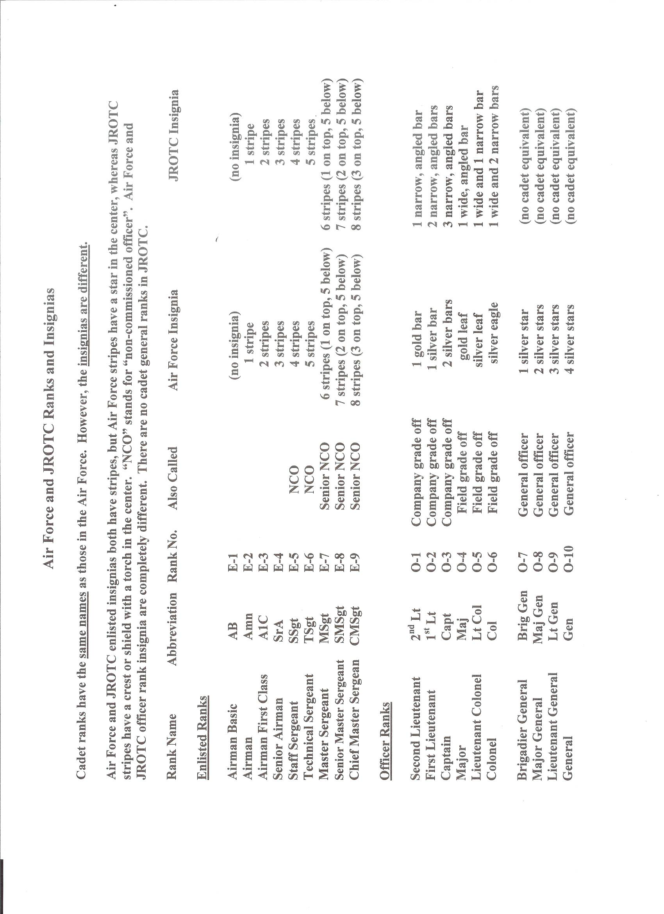

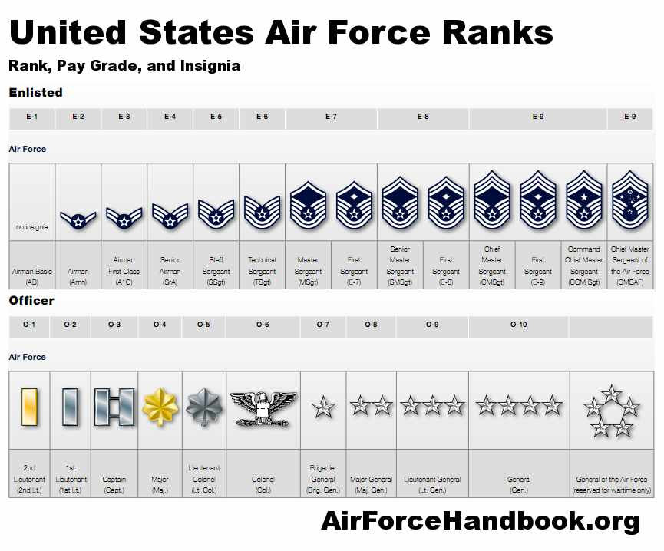

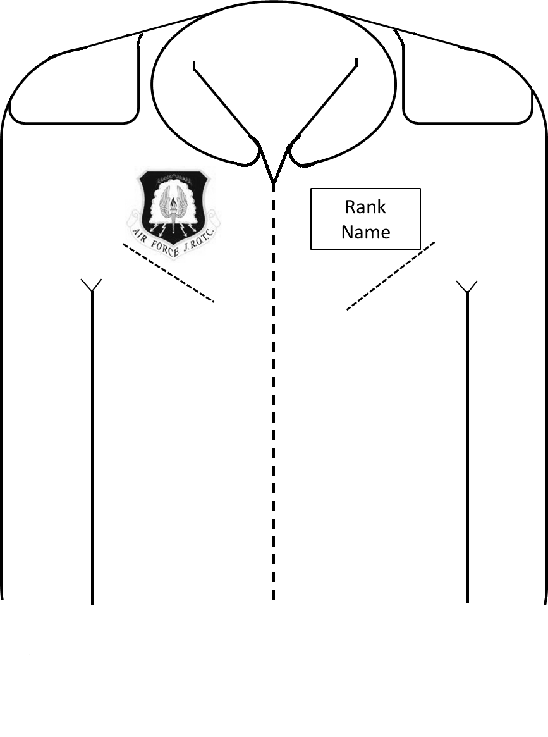
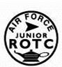
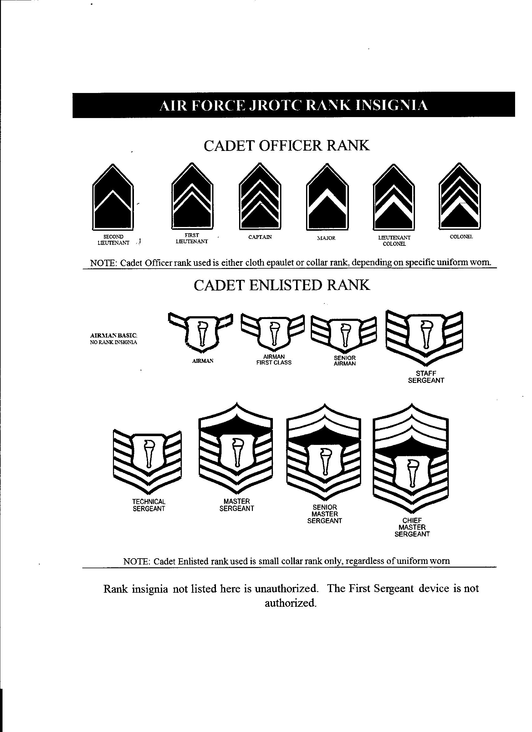

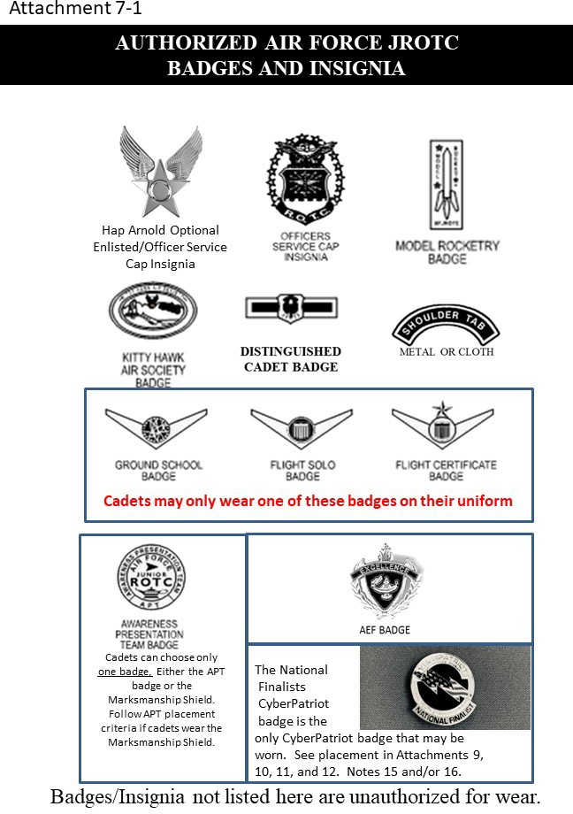

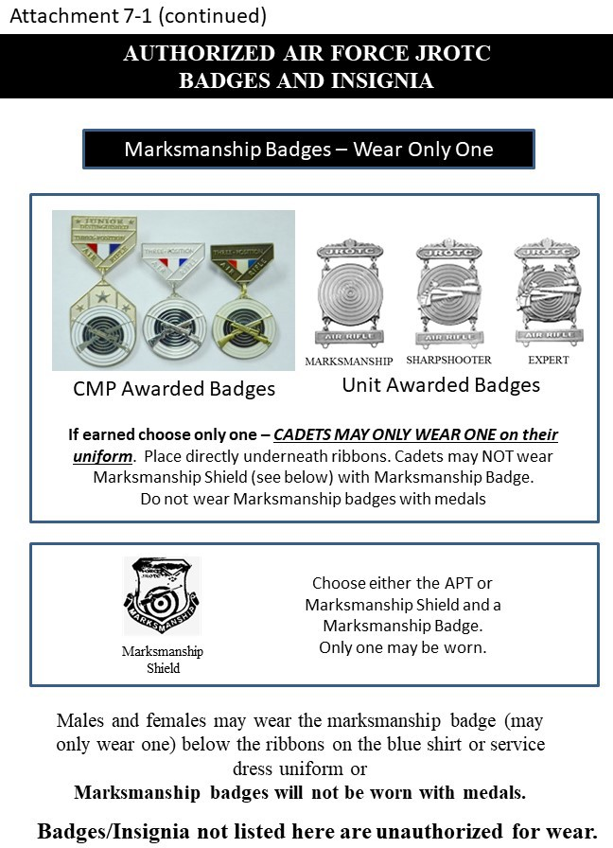
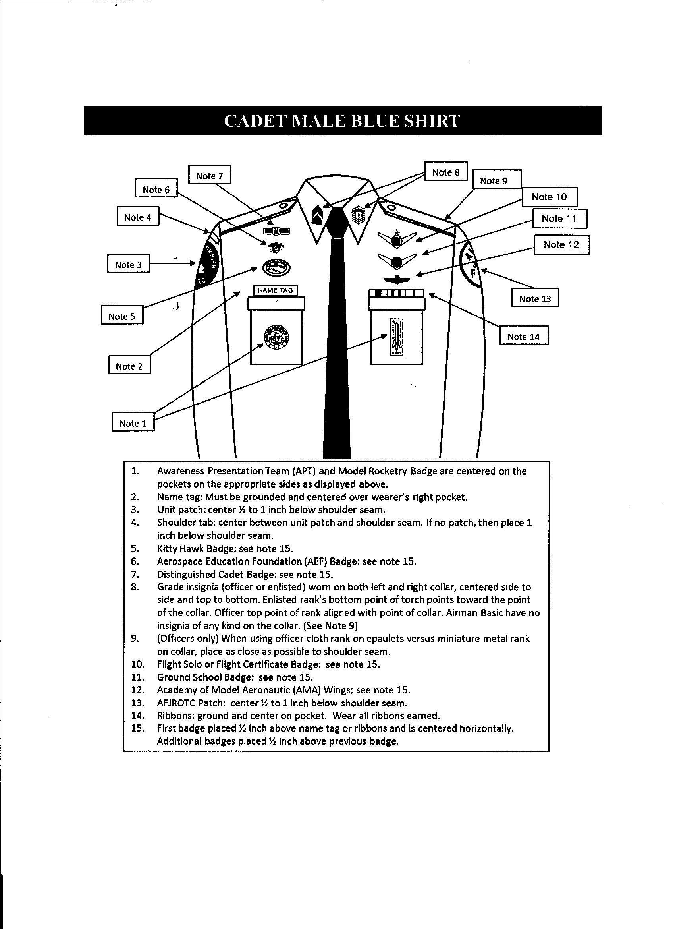
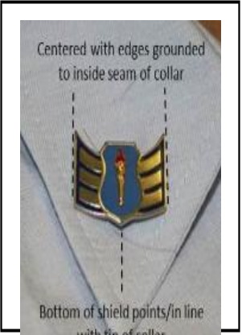
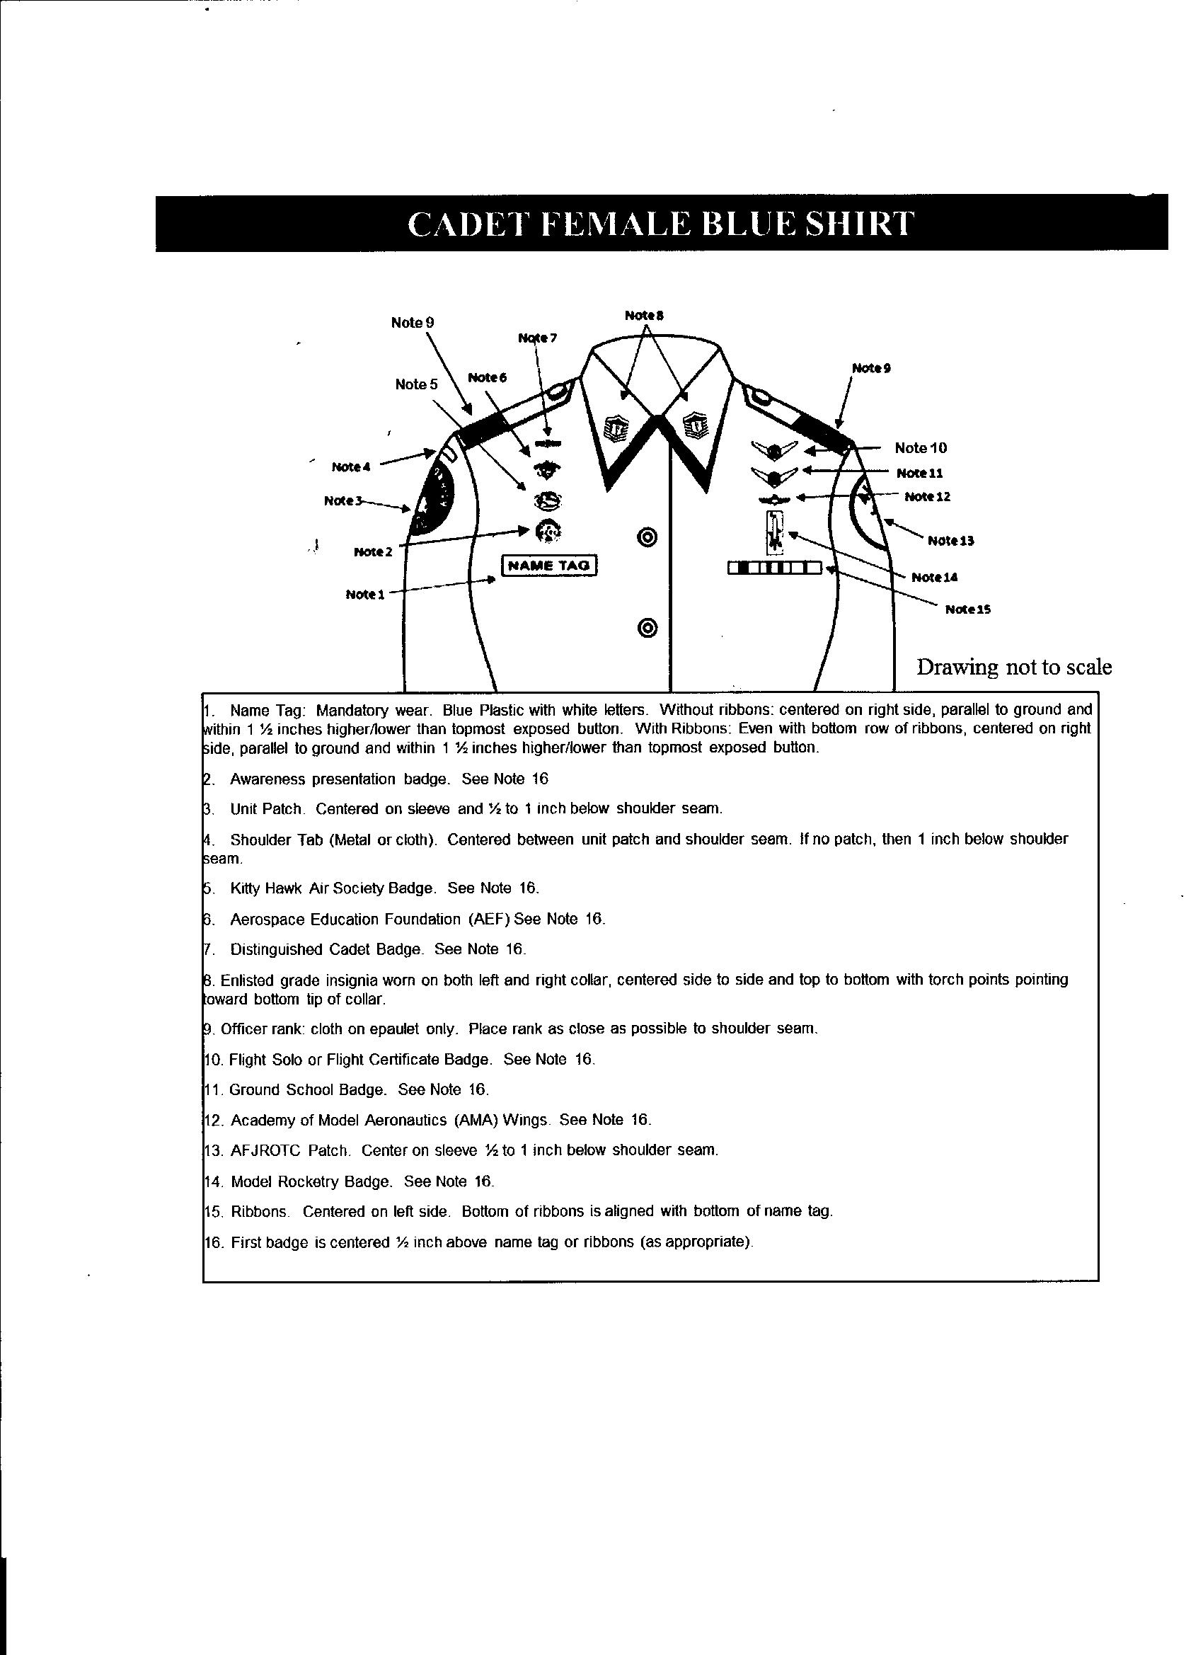
Princess cut shirts are authorized. Reimbursement will not exceed the cost of a shirt in FEDMALL and shirt will be loaded in Wings.
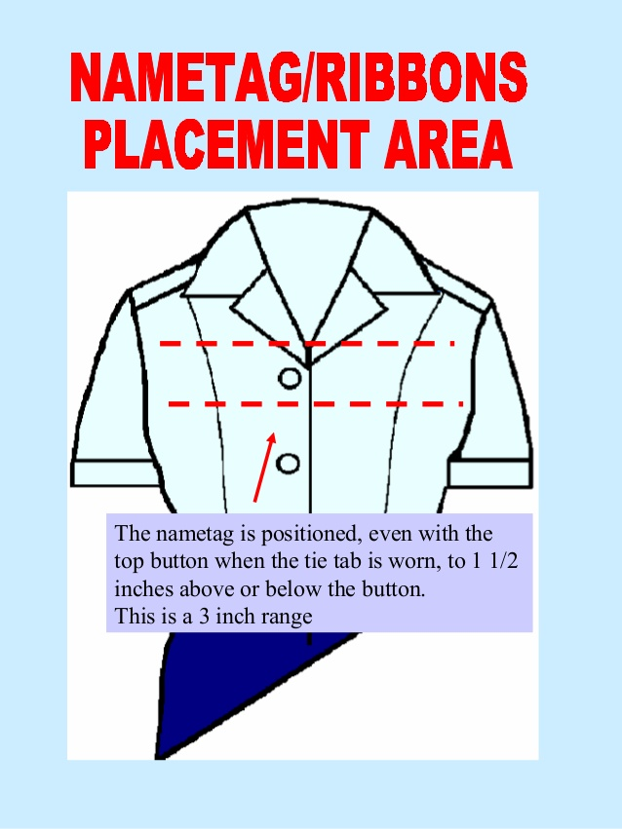
Cadet Male Service Dress
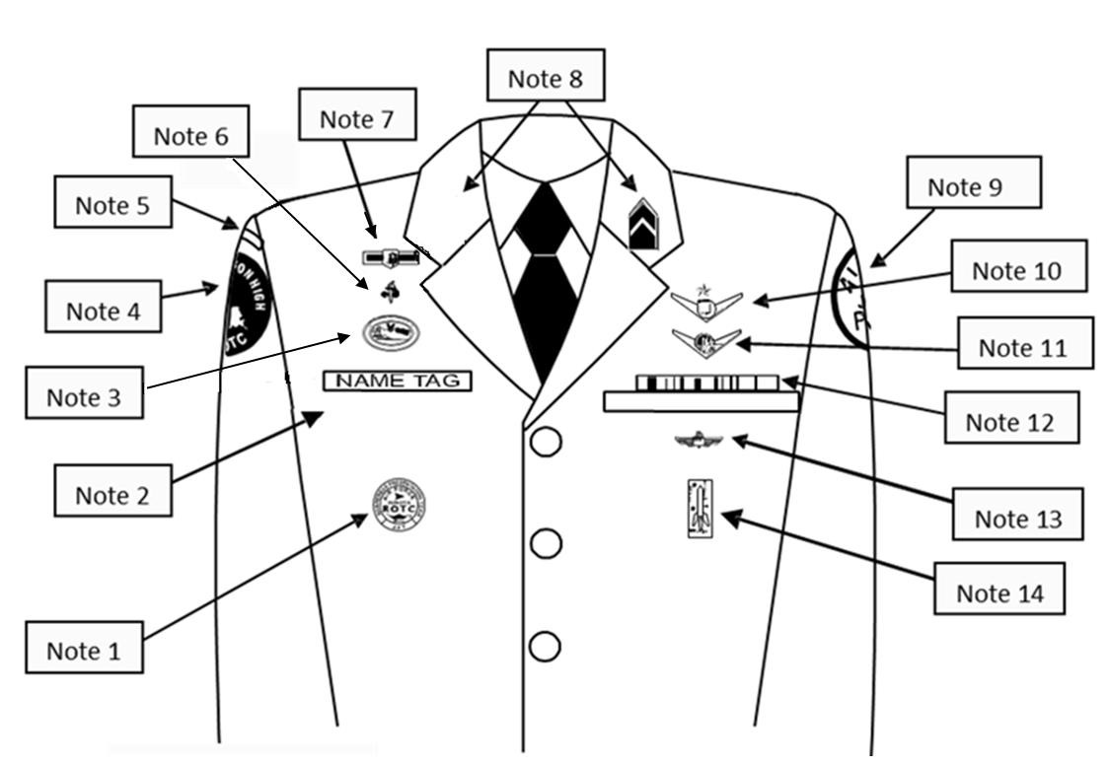



- Awareness Presentation Team (APT) Badge: Center 3 inches below bottom of the name tag.
- Silver Name tag: Mandatory wear. Center between arm seam and lapel with bottom edge parallel to top welt pocket.
- Kitty Hawk Badge: See Note 15
- Unit patch: Placed ½ to 1 inch below shoulder seam and centered.
- Shoulder tab: Only one is authorized and it will be centered between unit patch and shoulder seam. If no patch, then 1 inch below shoulder seam.
- Aerospace Education Foundation (AEF) Badge: See Note 15
- Distinguished Cadet Badge: See Note 15
- Grade insignia (officer or enlisted) worn on both lapels. Place insignia halfway up the seam, resting on but not over it. Bottom of insignia is horizontal with the ground. While wearing the service dress uniform enlisted cadets will wear rank on both shirt and jacket. Officer cadets may wear cloth epaulet rank while wearing the service dress uniform.
- AFJROTC patch: center ½ to 1 inch below shoulder seam
- Flight Solo or Flight Certificate Badge: See Note 15
- Ground School Badge: See Note 15
- Ribbons: center ribbons resting on but not over edge of welt pocket. Wear 3 or 4 in a row. Wear all ribbons earned
- Academy of Model Aeronautic (AMA) Wings: worn 1 inch below pocket
- Model Rocketry Badge: worn 2 inches below AMA Wings or 3 inches below pocket if no AMA Wings are worn.
- First badge placed ½ inch above name tag or ribbons (whichever is appropriate) and is centered horizontally. Additional badges place ½ above previous badge.

Large medals may be worn on the Service Dress coat only, directly under ribbon rack and only during special events (as determined by SASI). Cadet rank will be worn on shirt at all times even when wearing a service coat or L/W Blue Jacket. .Semi Formal Uniform Option SASI discretion: White Shirt, Black/Blue Bow Tie, or Blue Neck Tie and no Name Tag.

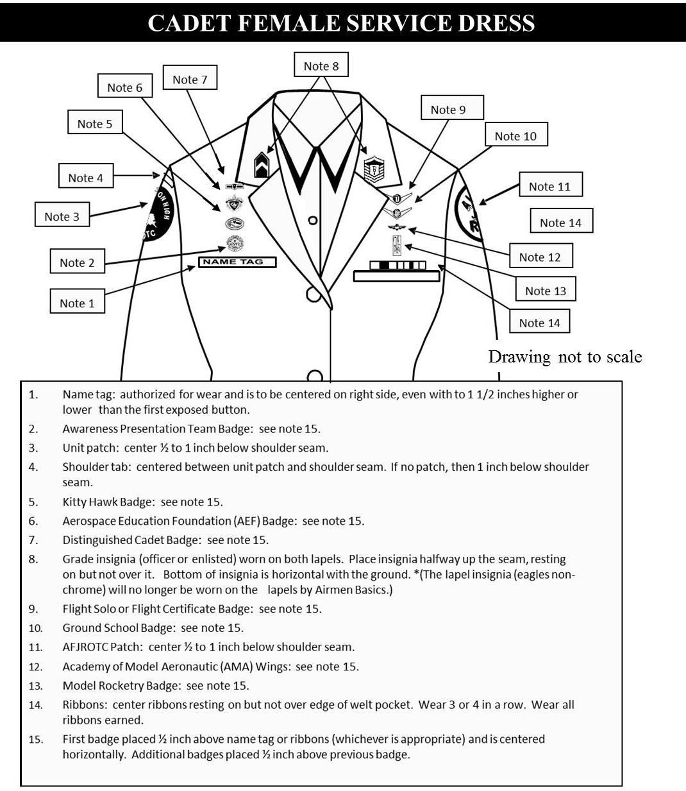

Large medals may be worn on the Service Dress coat only, directly under ribbon rack and only during special events (as determined by SASI).
Cadet rank will be worn on shirt at all times even when wearing a service coat or L/W Blue Jacket. .
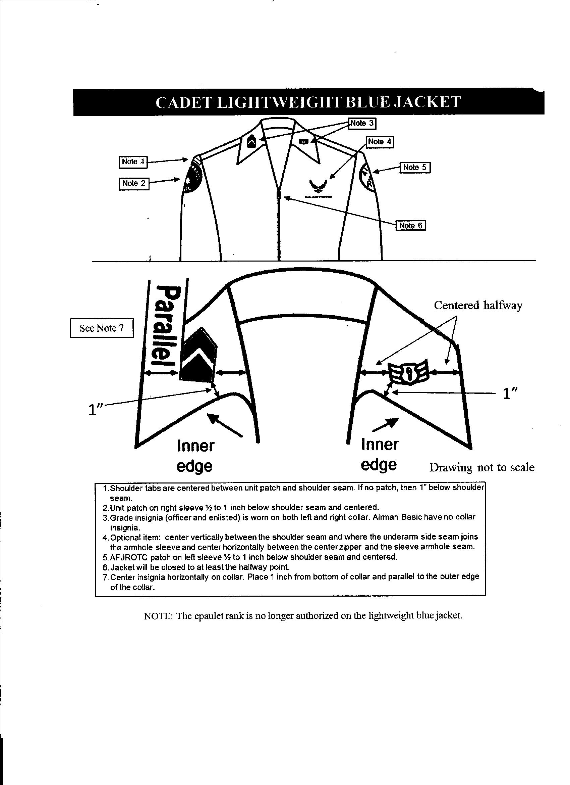
The epaulet rank (large size) is no longer authorized on the lightweight blue jacket and shoulder cords are not authorized for wear with this jacket.
Cadet rank will be worn on shirt at all times even when wearing a service coat or L/W Blue Jacket.

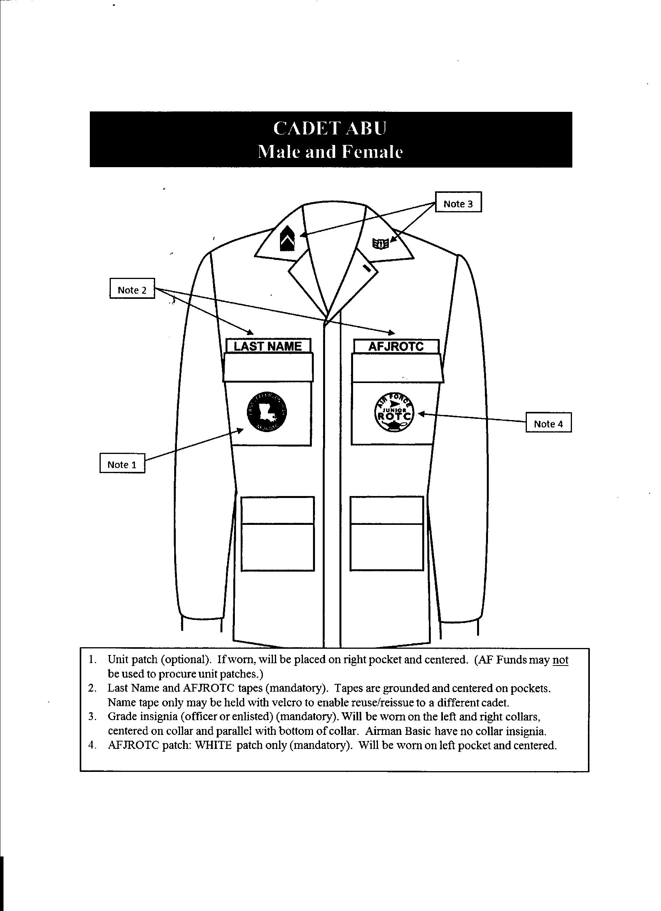
- Unit patch (optional). If worn, will be placed on right pocket and centered. (AF Funds may not be used to procure unit patches.)
- Last Name and AFJROTC tapes (mandatory). Tapes are grounded and centered on pockets. Name tape only may be held with velcro to enable reuse/reissue to a different cadet.
- Grade insignia (officer or enlisted) (mandatory). Will be worn on the left and right collars,
centered on collar and parallel with bottom of collar. Airman Basic have no collar insignia.
- AFJROTC patch: WHITE patch only (mandatory). Will be worn on left pocket and centered.
- Shoulder cords and ascots are not authorized for wear with this uniform.
- Only the ABU Cap (no berets or ball caps) will be worn with the ABU uniform.

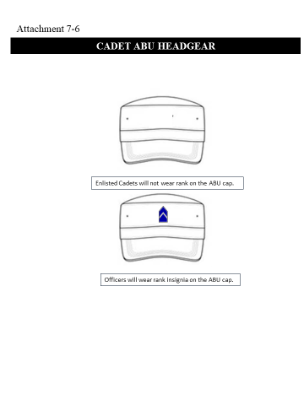

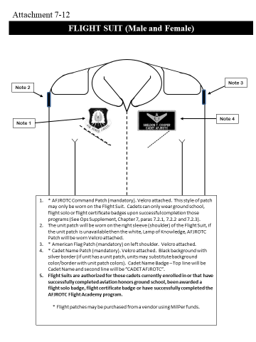
Only the ABU cap will be worn with the ABU uniform. There will be “NO” rank worn on the ABU cap.
1.* AFJROTC Command Patch (mandatory). Velcro attached. This style of patch may only be worn on the Flight Suit. Cadets can only wear ground school, flight solo or flight certificate badges upon successful completion those programs.
2.* AFJROTC (white “Lamp of Knowledge”) Patch (mandatory). Velcro attached.
3.* American Flag Patch (mandatory). Velcro attached.
4.* Cadet Rank and Cadet Name Patch (mandatory). Velcro attached. Black background with silver border/cadet rank/name.
5.Flight Suits are authorized for those cadets currently enrolled in or that have successfully completed aviation honors ground school, been awarded a flight solo badge, flight certificate badge or have successfully completed the AFJROTC Flight Academy program.
* Flight patches may be purchased from a vendor using MilPer funds

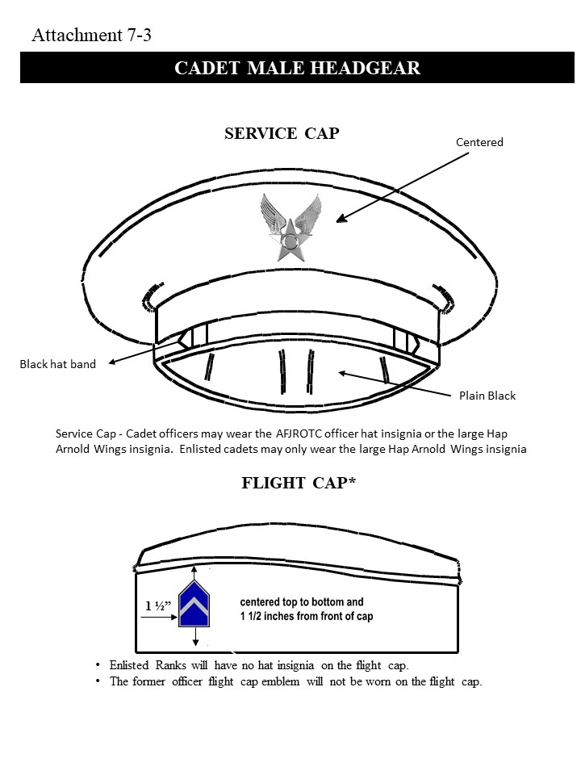

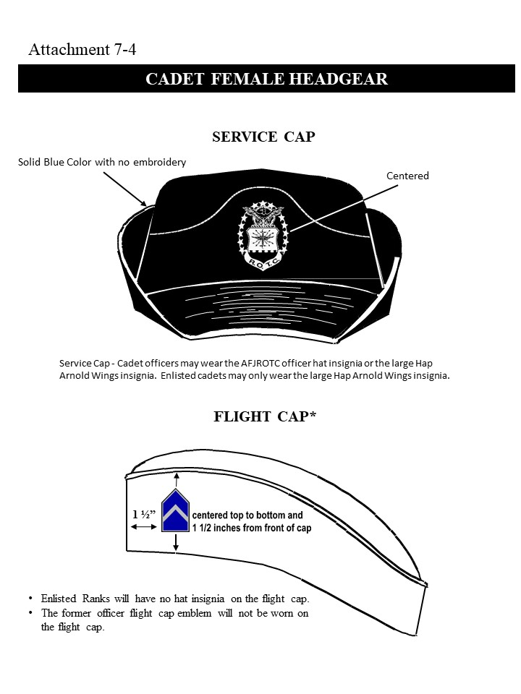

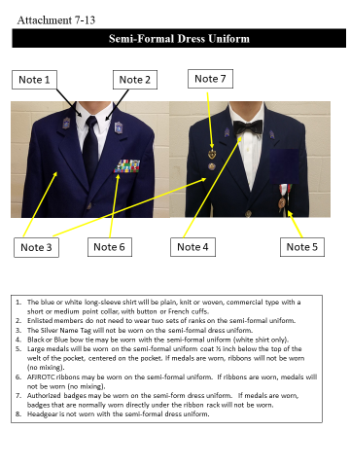

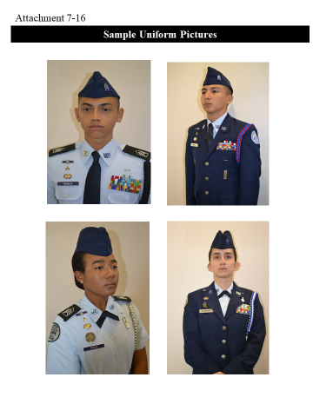

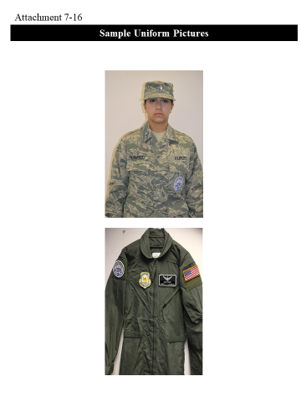

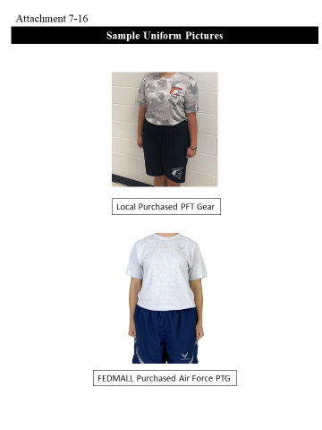
Each Friday you must wear Air Force PT gear during your AFJROTC class period. You may wear the Air Force T-Shirt all day as a “spirit” shirt. Wear of the PT gear on Friday is a graded activity.

Uniform and Awards

Foreword
AFJROTC cadets wear the same basic uniform as the active duty Air Force, and they should be expected to honor and wear the uniform properly and with pride. This chapter provides the latest guidance and clarification on AFJROTC uniform wear for instructors and cadets. It also provides guidelines for cadet appearance and grooming.
The AFJROTC Awards and Decorations Program recognize the achievements of AFJROTC cadets and fosters increased morale and espirit de corps. This chapter outlines the proper execution of a successful unit Awards and Decorations Program.

ACCOUTREMENTS
Insignia Placement. Insignia on the AFJROTC uniform will be worn according to the figures contained in this guide. Holm Center/JROS is the review/approval authority for waivers and for situations not specifically addressed by this guide.

Badges.
Ground School Badge. Awarded for successful completion of the AFJROTC aviation honors ground school curriculum or successful completion of another aviation ground school program prescribed by the FAA. To order the badge go to WINGS | Logistics | Create Display Orders.
Flight Solo Badge. Awarded to any cadet possessing a solo flight certificate signed by a FAA certified flight instructor for either powered or non-powered aircraft. Email HQ- Logistics@afjrotc.com a copy of the Cadets Flight Solo Certificate, and then go to WINGS | Logistics | Create Display Orders and order the Flight Solo Badge.

Flight Certificate Badge. Awarded to any cadet who possesses a valid FAA pilot’s certificate for either powered or non-powered aircraft. Email HQ-Logistics@afjrotc.com a copy of the Cadets Flight Solo Certificate, and then go to WINGS | Logistics | Create Display Orders and order the Pilot Certificate Badge.

Awareness Presentation Team Badge. Awarded for participation on an Awareness Presentation Team. Criteria for becoming a member of the team should be published in the Cadet Guide or the Unit Operating Instructions. Go to WINGS | Logistics | Create Display Orders and order the Awareness Presentation Team Badge.

Kitty Hawk Air Society Badge. Awarded to cadets who are members of the Kitty Hawk Air Society. The unit’s Kitty Hawk charter should spell out the requirements for entry into the society. Go to WINGS | Logistics | Create Display Orders and order the Kitty Hawk Air Society Badge.

Academy Modeling of Aeronautics (AMA) Wings. Awarded to cadets who are members of a local AMA chartered model airplane club. Contact the AMA to obtain badge for qualifying cadets.

Distinguished AFJROTC Cadet Badge. This annual award consists of a certificate and the Distinguished AFJROTC Cadet badge. The award recognizes one outstanding second- year cadet (third-year cadet in a 4-year program) selected at the end of each school year. This allows the recipient to wear the award their final year in the AFJROTC program. The recipient must be of high moral character, demonstrate positive personal attributes, display outstanding military potential, and maintain consistent academic and military excellence.
The SASI, in coordination with the ASI and with the concurrence of the principal, selects the recipient of this award. The Holm Center Form 308, Certificate of Recognition, is located in WINGS | Published Files | Directory | Certificates folder. The certificate is used to present with the badge. The unit must purchase the badge from a vendor. The recipient should hold the
following awards prior to selection:

• Leadership Ribbon
• Achievement Ribbon
• Superior Performance Ribbon
• Academic Ribbon
• Co-curricular Activities Leadership Ribbon
• Service Ribbon

Aerospace Education Foundation (AEF) Academic Cadet Badge. Awarded to rising Junior and Senior cadets for academic excellence as signified by attaining an overall 3.3 grade point average with no grade below “C” on their transcript. The individuals must be recommended by the SASI. Go to WINGS | Logistics | Create Display Orders and order the AEF Badge.

Model Rocketry Badge. Awarded to cadets who have fulfilled model rocketry program requirements. Program requirements are listed in the Model Rocketry Handbook available in WINGS | Published Files | Directory | JROTC | Instruction and Guides | Model Rocketry Handbook. OPR: Holm Center/JROSL.

Other Badges or Pins.
• Sister Service: Only cadets who were previously enrolled in a sister service JROTC program may wear the badges or pins earned on their AFJROTC uniform in the location specified by the sister service. In a conflict, the AFJROTC badge location will always take precedence over the sister service badge/pin. • Any badge or pin not specifically authorized by HQ AFJROTC will not be worn on any AFJROTC uniform combination. (Refer to Attachment 7-1)
Marksmanship Awards. Marksmanship competition awards/badges may be worn on the AFJROTC uniform. Males wear the badges under the ribbons on the left pocket flap of the light blue shirt or below the ribbons on the service dress uniform. Females wear the badges above the ribbons on both uniforms.

Shoulder Patches.
AFJROTC Patch. Wear of the AFJROTC official shoulder patch is mandatory on the left sleeve of all uniforms except the raincoat, overcoat, and all-weather coat. Cadets enrolled in Civil Air Patrol (CAP) and AFJROTC who use the same uniform for both activities may wear the CAP wing patch on the right shoulder sleeve.

Unit Patch. Optional. If worn, must be on the right shoulder only. Unit patches are paid for by non-AF Funds. Unit patches must be approved by HQ AFJROTC via the waivers module in WINGS prior to purchase or use.

Shoulder Cords. Cadets are authorized to wear one shoulder cord (double knot, single cord – no aiguillettes or citation cords) on the left shoulder. This will be a single “infantry” style cord, without metal tips, no more than 1-inch wide. Wear the shoulder cord only on the light blue shirt and the service dress coat. The SASI will designate criteria on who may wear shoulder cords. For Corsicana High School, shoulder cords will only be worn by those on color guard and those cadets who have a staff position. For color guard, an individual must have completed at the minimum five color guard practices and performed in five color guard events. Color guard events include local presentations of colors and competing with the color guard drill teams. On the service dress coat, cords should be pinned to the shoulder with the pin hidden beneath the cord.

AWARDS AND DECORATIONS

Awards and Decorations. The Cadet Awards and Decorations Program fosters morale, esprit de corps, and recognizes achievements of AFJROTC cadets. Awards sponsored by national organizations are funded by the sponsoring organization and donated through local chapters where available. Only Awards and Decorations approved by Holm Center/JR and listed in this guide may be worn.

Minimum criteria are prescribed to preserve the integrity of decorations. Units are authorized to impose additional criteria (more stringent) to meet local standards and needs without diminishing minimum standards (example: limiting the amount of cadets who may earn the award where no guidance is stated, or below stated limits). If such additional criteria are imposed, they must be specifically stated in the Cadet Guide or Unit Operating Instructions.

Present awards at appropriate ceremonies. Invite school officials, local civil authorities and parents when practical. Representatives from organizations sponsoring awards should be offered the opportunity to make the award presentation. Display awards when possible for the benefit of the cadet corps..

Guidelines for National Awards should be followed to the fullest extent possible; however, SASIs have latitude to approve awarding of National Awards to deserving cadets that do not meet award criteria (i.e., a deserving sophomore instead of a junior, there is not a deserving cadet who meets an awards class standing percentage criteria established for the award, etc.). If there are deviations from established award criteria, the “spirit of intent” of an award’s must be maintained. Whenever possible, obtain approval from the sponsoring organization’s local chapter for any deviations from established criteria. An award’s sponsoring organization may require a written report before final cadet selection or after presentation is made. Reports may include information such as: name of the award; name(s) of recipient, place and date of presentation, occasion (graduation, awards banquet, etc.,), and name, title, and organization of award presenter. The SASI is responsible to ensure any required reports are accomplished.

Order of Precedence of AFJROTC medals and ribbons.

AFJROTC Awards.

- Gold Valor Award (Medal/Ribbon)
- Silver Valor Award (Medal/Ribbon)
- Cadet Humanitarian Award (Ribbon)
- Silver Star Community Service with Excellence Ribbon
- Community Service with Excellence Ribbon
- Air Force Association Award (Medal/Ribbon)
- Daedalian Award (Medal/Ribbon)
- Daughters of the American Revolution Award (Medal and Ribbon)
- American Legion Scholastic Award (Medal/Ribbon)
- American Legion Military Excellence Award (Medal and Ribbon)
- Reserve Officers Association Award (Medal/Ribbon)
- Military Officers Association Award (Medal/Ribbon)
- Veterans of Foreign Wars (VFW) Award (Medal/Ribbon)
- National Society United States Daughters of 1812 (Medal and Ribbon)
- National Sojourners Award (Medal and Ribbon)
- Scottish Rite, Southern Jurisdiction Award (Medal and Ribbon)
- Military Order of the Purple Heart Award (Medal/Ribbon)
- Sons of the American Revolution Award (Medal and Ribbon)
- Military Order of World Wars Award (Medal/Ribbon)
- American Veterans Award (Medal/Ribbon)
- Air Force Sergeants Association (AFSA) Award (Medal/Ribbon)
- Tuskegee Airmen Incorporated AFJROTC Cadet Award (Ribbon)
- The Retired Enlisted Association Award (Medal/Ribbon)
- The Celebrate Freedom Foundation Award (Medal/Ribbon)
- Air Commando Association Award (Medal/Ribbon)
- Distinguished Unit Award with Merit (Ribbon)
- Distinguished Unit Award (Ribbon)
- Outstanding Organization Award (Ribbon)
- Outstanding Flight Ribbon
- Top Performer Ribbon
- Outstanding Cadet Ribbon
- Leadership Ribbon
- Achievement Ribbon
- Superior Performance Ribbon
- Academic Ribbon
- Cadet Leadership Course Ribbon
- Special Teams Placement Ribbon
- All Services National Competition (Medal/Ribbon)
- Air Force Nationals Competition (Medal/Ribbon)
- Orienteering Ribbon
- Leadership Development Requirement (LDR) Leadership Ribbon
- Drill Team Ribbon
- Color Guard Ribbon
- Saber Team Ribbon
- Marksmanship Ribbon
- Good Conduct Ribbon
- Service Ribbon
- Health and Wellness
- Recruiting Ribbon
- Activities Ribbon
- Attendance Ribbon
- Dress and Appearance Ribbon
- Longevity Ribbon
- Bataan Death March Memorial Hike Ribbon
- Patriotic Flag Ribbon

Special Awards.

1. Gold Valor Award 2. Silver Valor Award 3. Cadet Humanitarian Award 4. Silver Star Community Service with Excellence Award 5. Community Service with Excellence Award

National Awards.

6. Air Force Association Award 7. Daedalian Award 8. Daughters of the American Revolution, 9. American Legion Scholastic Award 10. American Legion General Military Excellence Award 11. Reserve Officers Association Award 12. Military Officers Association Award, 13. Veterans of Foreign Wars, 14. National Society United States Daughter of 1812, 15. National Sojourners Award , 16. Scottish Rite, Southern Jurisdiction Award, 17. Military Order of the Purple Heart Award, 18. Sons of the American Revolution Award, 19. Military Order of World Wars Award, 20. American Veterans Award, 21. Air Force Sergeants Association Award, 22. Tuskegee Airmen Incorporated AFJROTC Cadet Award, 23. The Retired Enlisted Association Award, 24. The Celebrate Freedom Foundation Award, 25. Air Commando Association Award.

28. Non-Funded National Awards (i.e., NCOA, National Society, Daughters of Founders and Patriots of America, etc.) (Organization must be submitted to and approved by HQ AFJROTC: award criteria must be published in the Unit’s Cadet Guide or Operating Instruction)

AFJROTC Awards.

AFJROTC cadets are not authorized to wear ribbons/medals earned/issued from Army, Navy, Marine Corps, or Coast Guard Junior ROTC programs. Cadets will be given equivalent AFJROTC ribbons to wear in lieu of Army, Navy, Marine Corps, or Coast Guard Junior ROTC ribbons/medals the cadet earned while serving in sister-service JROTC program. It is up to the SASI to make the best determination as to what equivalent AFJROTC ribbon to issue.

Badges or insignia from Active Duty, Guard, Reserve, or any other non-AFJROTC group are not authorized on the AFJROTC uniform. Badges, ribbons or insignia from middle school programs such as Youth Leadership Corps are not authorized on the AFJROTC uniform.

Descriptions and Criteria of AFJROTC Medals and Ribbons. Ribbons will not be worn with Medals (only the medals will be worn). NOTE: Medals will not be worn on regular uniform days or during any type of competition, i.e., drill, Cyber-Patriot, Academic Bowl, etc.

Awards: As you read through this next section, you will see that there are many awards you could be eligible for. The requirements to earn these awards are listed. The SASI, ASI, and the senior cadet staff want you to know that you are constantly being observed. These observations will help them in determining if an individual has met the award’s requirements. We also want you to know that the senior cadet officers will also help in making these determinations – they have the responsibility to recommend only. However, their input is very important to the SASI and ASI and will be taken seriously. Always do your best.

Descriptions and Criteria.

Gold Valor Award. Awards consist of a medal, ribbon, and certificate. The Gold Valor Award recognizes the most outstanding voluntary acts of self-sacrifice and personal bravery by a cadet involving conspicuous risk of life above and beyond the call of duty.
Forward recommendations for valor awards through HQ-OpsSupport@afjrotc.com for review and approval within 6 months of the incident. Include a detailed description of the situation, newspaper clippings (if available), statements by victims and observers, and any other information deemed appropriate to validate eligibility. In addition, submit a proposed citation to accompany the award. HQ-Ops Support will forward the valor award to the HQ AFJROTC Director for final approval. Upon approval, Operation Support will distribute the citation, medal, and ribbon for presentation.

Silver Valor Award. Awards consist of a medal, ribbon, and certificate. The Silver Valor Award is awarded to a cadet for a voluntary act of heroism which does not meet the riskof-life requirements of the Gold Valor Award.
Forward recommendations for valor awards through HQ-OpsSupport@afjrotc.com for review and approval within 6 months of the incident. Include a detailed description of the situation, newspaper clippings (if available), statements by victims and observers, and any other information deemed appropriate to validate eligibility. In addition, submit a proposed citation to accompany the award. HQ-Ops Support will forward the valor award to HQ AFJROTC Director for final approval. Upon approval, HQ-OpsSupport@afjrotc.com distributes the citation, medal, and ribbon for presentation.

Cadet Humanitarian Award. Award consists of a ribbon and certificate. It is intended to recognize cadets who provide aid in response to a singular extraordinary event such as a natural disaster or other catastrophe that has placed or has the potential to place a hardship on their fellow citizens. This award is not to be used to recognize day-to-day service in the community.
Forward recommendations for humanitarian awards to HQ-OpsSupport@afjrotc.com for review and approval within 6 months of the incident. Include a detailed description of the situation, newspaper clippings (if available), statements by victims and observers, and any other information deemed appropriate to validate eligibility. In addition, submit a proposed citation to accompany the award. Upon approval, HQ-Ops Support distributes the citation and ribbon for presentation.

Silver Star Community Service with Excellence Award. Award consists of a ribbon with silver star device and certificate. The Silver Star Community Service with Excellence Award will be an honor that emphasizes the value of community service, and establishes a greater sense of pride within the corps.

• The award will be given to cadets in the Top 5% of units (approximately 45 units) who have the highest "per cadet average" community service hours. • "Countable" hours must be logged into WINGS and be accomplished IAW published guidance (AFJROTCI 36-2001, Part 7) • Countable hours will be the period from 11 April (previous year) to 10 Apr (current year). HQ will use the last PSR cadet enrollment and the hours submitted in WINGS for that period to calculate the Top 5% units and notify the units earning the Award. • Instructors at the Top 5% units will determine which of their cadets have contributed to the unit earning the new award.

Community Service with Excellence Award. Award consists of a ribbon and certificate. It is intended to recognize those individual cadets who provide significant leadership in the planning, organizing, directing, and executing of a major unit community service project that greatly benefit the local community. This is not an award given to participants but to the key leader(s) of the project.

Forward recommendations for Community Service with Excellence Award to HQ- OpsSupport@afjrotc.com for review and approval within 6 months of completion of the project. Include a detailed description of the contributions of the individual(s) along with newspaper clippings (if available) describing the outcome of the project, letters of appreciation from civic leaders, or other information deemed appropriate to validate eligibility. Ribbon must be purchased from a local vendor using MilPer funds.

Air Force Association (AFA) Award. This AFA-sponsored award consists of a medal and ribbon and is presented annually at each unit to the outstanding second-year (in a 3- year program) or third-year cadet (in a 4-year program).
The award recipient must possess/meet the following personal characteristics and eligibility criteria:

• Positive attitude (toward AFJROTC and school).
• Outstanding personal appearance (uniform and grooming).
• Display personal attributes such as initiative, judgment, and self-confidence. Courteous demeanor (promptness, obedience, and respect for customs).

Daedalian Award. The Order of Daedalians is a fraternity of commissioned pilots from all military services. It is named after the legendary figure, Daedalus, and was organized by WWI military pilots who sought to perpetuate the spirit of patriotism, love of country, and the high ideals of self-sacrifice which place service to the nation above personal safety and position. This award is offered to encourage the development of these traits in cadets and to interest them in a military career. The medal is fashioned after an ancient Grecian plaque discovered by a Daedalian in the village of Lavadia, Greece and depicts Daedalus and his son Icarus fabricating their legendary wings of wax and feathers. The award also includes a ribbon.
This annual award recognizes one outstanding third-year cadet at each unit that meets the following criteria:

• Demonstrate an understanding and appreciation of patriotism, love of country, • and service to the nation.
• Indicate the potential and desire to pursue a military career.
• Rank in the top 10% of their AFJROTC class.
• Rank in the top 20% of their school class.

The SASI selects the recipient and requests the award from the nearest Daedalian Flight. A minimum of 90 days’ notice is required to allow the local chapter to obtain the award from their national headquarters and to schedule a Daedalian Flight presenter for the award. See Attachment 11 for list of award points of contact.

American Legion Scholastic Award. This award consists of a bronze medal accompanied by a ribbon with a distinctive miniature attachment depicting a scholastic scroll.
This award is presented annually to one second- or third-year cadet (in a 3-year program) or a third- or fourth-year cadet (in a 4-year program) based on the cadet’s overall scholastic achievements. Each cadet must:

• Rank in the top 10% of the high school class.
• Rank in the top 25% of their AFJROTC class.
• Demonstrate leadership qualities.
• Actively participate in student activities
The SASI, as chairman, with the ASI and at least one faculty member, selects the recipient and must request the award not later than 15 April. The award devices and presenter can be requested from the nearest American Legion Post. If there is no local post, contact the American Legion Headquarters. See Attachment 6-11 for list of award points of contact.

American Legion General Military Excellence Award. This award consists of a bronze medal accompanied by a ribbon with a distinctive miniature attachment depicting a torch.
This award is presented annually to one second- or third-year cadet (in a 3-year program) or a third- or fourth-year cadet (in a 4-year program) based on the cadet’s general military excellence. Each cadet must:

• Rank in the top 25% of their AFJROTC class.
• Demonstrate outstanding qualities in military leadership, discipline, character, and citizenship.
The SASI, as chairman, with the ASI and at least one faculty member, selects the recipient and must request the award not later than 15 April. The award devices and presenter can be requested from the nearest American Legion Post. If there is no local post, contact the American Legion Headquarters. See Attachment 6-11 for list of award points of contact.

Daughters of the American Revolution (DAR) Award. This award consists of a bronze medal and ribbon.

This award is presented annually to one third-year (in a 3-year program) or fourth- year cadet (in a 4-year program) that meets the following criteria:
• Rank in the top 25% of their AFJROTC class.
• Rank in the top 25% of their high school class.
• Demonstrate qualities of dependability and good character.
• Demonstrate adherence to military discipline.
• Possess leadership ability and a fundamental and patriotic understanding of the importance of JROTC training.

The SASI and principal select the recipient and must request the award and a presenter not later than 1 March. The award devices and presenter can be requested from the nearest DAR chapter. See Attachment 6-11 for list of award points of contact.

American Veterans (AMVETS) Award. This award consists of a medal pendant and ribbon.
This award is presented annually to one qualified cadet that possesses individual characteristics contributing to leadership such as:

• A positive attitude toward AFJROTC programs and service in the Air Force.
• Personal appearance (wearing of the uniform, posture, and grooming, but not physical characteristics per se).
• Personal attributes (initiative, dependability, judgment, and self-confidence).
• Officer potential (capacity for responsibility, adaptability, and maintenance of high personal standards).
• Obtained a grade of “A” (or the numerical equivalent) in their AS class.
• Be in good scholastic standing in all classes at the time of selection and at the time of presentation.

The SASI selects the recipient of the award and submits a brief nomination letter and biographical sketch of the cadet to the state AMVETS department where the school is located. An AMVETS representative should make the presentation if a participating local post or department representative is available. See Attachment 6-11 for list of award points of contact.
Reserve Officers Association (ROA) Award. This award consists of a bronze medal, ribbon, and certificate. This award is presented annually for military and academic achievement to an outstanding third-year cadet (fourth-year cadet in a 4-year program). The recipient must possess individual characteristics contributing to leadership such as:

• Positive attitude toward the AS curriculum.
• Outstanding personal appearance (wear of the uniform, posture, and grooming).
• Attributes of initiative, judgment, and self-confidence.
• Courtesy (promptness, obedience, and respect).
• Growth potential (capacity for responsibility, high productivity, adaptability to change).
• Demonstrate the highest personal, ethical standards & strong positive convictions.
• Rank in the top 10% of their AS class.

The SASI, as chairman, with the ASI and at least one faculty member, selects the recipient of the award. The local ROA chapter contacts each ASI before 15 Sept and furnishes the name of the ROA representative for presentation purposes. If no contact is made by 15 Sept, the SASI must communicate directly with the National Headquarters of the Reserve Officers Association.

Military Order of World Wars Award. This award consists of a bronze medal pendant, certificate, and ribbon. This award is presented annually to an outstanding cadet who has committed to continue the aerospace science program the following school year. The SASI, with the concurrence of the principal, selects the recipient and completes the Military Order of the World Wars (MOWW) citation by summarizing the cadet’s outstanding accomplishments or service to the unit. The citation and request for the medal, certificate, and ribbon are sent to the nearest local chapter of the MOWW. The SASI will make arrangements for a MOWW representative to make the presentation at an appropriate ceremony. If a local chapter is unavailable, contact the MOWW National Headquarters. If a member is not available, any active, reserve, or retired commissioned officer may present the award.

Military Officers Association of America (MOAA) Award. This award, formerly known as The Retired Officers Association Award, consists of a medal pendant with ribbon.
This award is presented annually to an outstanding second-year cadet (third-year cadet in a 4-year program) who shows exceptional potential for military leadership. Each cadet must:

• Be a member of the junior class.
• Be in good academic standing.
• Be of high moral character.
• Show a high order of loyalty to the unit, school, and country.
• Show exceptional potential for military leadership.

The SASI selects the recipient subject to the final approval of the sponsoring MOAA chapter. The SASI requests the award devices from the nearest MOAA chapter. A MOAA representative will make the award presentation. If a MOAA chapter is not available in the area, the SASI sends the request to the MOAA headquarters.

Veterans of Foreign Wars (VFW) Award. This award consists of a medal pendant with ribbon This award presented annually to an outstanding second- or third-year cadet in a 3-year program (third- or fourth-year cadet in a 4-year program) who is actively engaged in the AFJROTC program and who possesses individual characteristics contributing to leadership. Each cadet must:

• Have a positive attitude toward AFJROTC.
• Have outstanding military bearing and conduct.
• Possess strong positive personal attributes (such as courtesy, dependability, punctuality, respect, and cooperation).
• Demonstrate patriotism (being a member of the color guard or drill team) and actively promote Americanism.
• Demonstrate leadership potential.
• Attain a grade of “B” in AFJROTC with an overall average grade of “C” in all subjects for the previous semester.
• Be active in student activities.
• Not have been previous recipients of this award.

The SASI selects the recipient subject to the final approval of the sponsoring VFW chapter. The SASI requests the award from the nearest local post in February for presentation in April or May. A VFW representative will present the award at an appropriate ceremony. If no local post is available, or if the local post does not offer the award, obtain information by contacting the headquarters of the Veterans of Foreign Wars of the United States.

National Sojourners Award. This award consists of a ribbon, medal pendant, and certificate. This award is presented annually recognizing an outstanding first- or second-year cadet (second or third-year cadet in a 4-year program) who contributed the most to encourage and demonstrate Americanism within the corps of cadets and on campus. Each cadet must:

• Be in the top 25% of their academic class.
• Encourage and demonstrate ideals of Americanism.
• Demonstrate potential for outstanding leadership.
• Not have previously received the award.

The SASI selects the recipient subject to the final approval of the sponsoring National Sojourners chapter. The SASI requests the award from the nearest local chapter in February for presentation in April or May. A representative from the National Sojourners will make the award presentation at an appropriate ceremony. If no local chapter is available or if the local chapter does not offer the award, contact the headquarters of the National Sojourners.

Sons of the American Revolution (SAR) Award. This award consists of a bronze medal with ribbon. This award recognizes an outstanding second-year cadet in a 3-year program or third year cadet in a 4-year program who is enrolled in the AFJROTC program. The recipient must exhibit a high degree of leadership, military bearing, and all-around excellence in AS studies and not have previously received the award. Each cadet must:

• Be currently enrolled in the AFJROTC program.
• Be in the top 10% of their AFJROTC class.
• Be in the top 25% of their overall class.

The SASI and the Principal select the recipient of the award not later than 1 March. The SAR national headquarters furnishes the secretary of each applicable SAR state organization a list of the AFJROTC units in their state. A representative of SAR will present the award and correspond directly with each unit within their area. The SASI makes arrangements for presentation with the applicable state society or local chapter
Scottish Rite, Southern Jurisdiction Award. This award consists of a medal, ribbon, and certificate. This award annually recognizes an outstanding second-year cadet in a 3-year program or third-year cadet in a 4-year program. Each cadet must:

• Contribute the most to encourage Americanism by participation in Co-Curricular activities or community projects.
• Demonstrate academic excellence by being in the top 25% of class.
• Demonstrate the qualities of dependability, good character, self-discipline, good citizenship and patriotism.
• Not have been previous recipients of this award.

The SASI selects the recipient and requests the award from the nearest Scottish Rite Valley of the Southern Jurisdiction at any time during the calendar year. With a 30- day notice, a representative of the Scottish Rite Valley of the Southern Jurisdiction will make the presentation at an appropriate ceremony. If no local unit is available, or if the local unit does not offer the award, obtain information by contacting the national headquarters of the Scottish Rite Valley of the Southern Jurisdiction. The star worn on the ribbon must be procured with private or unit funds and will not be furnished by the sponsoring organization.

Military Order of the Purple Heart Award. This award consists of a medal pendant with a ribbon. This award annually recognizes an outstanding (first, second, or third-year cadet), who is enrolled in the AFJROTC program and demonstrates leadership ability. (Seniors are not eligible) Each cadet must:

• Have a positive attitude toward AFJROTC and country.
• Hold a leadership position in the cadet corps.
• Be active in school and community affairs.
• Attain a grade of “B” or better in all subjects for the previous semester.
• Not have been a previous recipient of this award.

The SASI selects the recipient and requests the award from the nearest Military Order of the Purple Heart unit in February for presentation in April or May. A representative of the Military Order of the Purple Heart will make the presentation at an appropriate ceremony. If no local unit is available, or if the local unit does not offer the award, obtain information by contacting the national headquarters of the Military Order of the Purple Heart.

Air Force Sergeants Association (AFSA) Award. This annual award consists of a medal pendant with a ribbon. This award recognizes an outstanding second- or third-year cadet in a three-year program (third- or fourth-year cadet in a 4-year program). The recipient must demonstrate outstanding qualities in military leadership, discipline, character, and citizenship. Each cadet must:

• Be in the top 10% of the AFJROTC class.
• Demonstrate outstanding qualities in military leadership, discipline, character, and citizenship.
• Not have been a previous recipient of this award.

The SASI, as chairperson, with the ASI, recommends the recipient of the award at least 60 days prior to the desired presentation date, but not later than 15 April. The SASI requests the award and an AFSA presenter from the nearest AFSA chapter. If information on the nearest chapter is not available, or if there is no active AFSA chapter in the area, the SASI will contact the AFSA international headquarters; (please send an email to AFSA HQ at bhill@hqafsa.org) to obtain the name and address of the division president whose area of responsibility is nearest the requesting school.

Sons of Union Veterans of the Civil War (SUVCW) Award. This award consists of a medal pendant with a ribbon. This award recognizes one deserving cadet annually (may be first, second, third, or fourth year cadet). The recipient must display a high degree of patriotism and have demonstrated a high degree of academic excellence and leadership ability.
The SASI and ASI select the recipient and must request presentation materials from a local camp or the respective SUVCW state department. The contact information for the state departments or local camps is located on the SUVCW website.

Sons of Confederate Veterans H. L. Hunley Award. This award should go to a rising second year cadet who has demonstrated the qualities of Honor, Courage and in particular Commitment to his/her unit throughout the school year. This award consists of a Medal ribbon and a certificate.

Tuskegee Airmen Incorporated (TAI) Air Force JROTC Cadet Award. This TAI sponsored award consists of a ribbon and a certificate. This award is presented annually to two cadets. Cadets may be first-year, second-year, or third-year cadets (in a 3- or 4-year program) and must meet the following criteria:

• Attain a grade of “B” or better in their AS class.
• Be in good academic standing.
• Actively participate in cadet corps activities.
• Participate in at least 50% of all unit service programs.

The SASI and ASI select the recipients. This award is mailed to all units proactively by AFJROTC Unit NC-051, Central Cabarrus High School not later than 1 March. AFJROTC NC-051, Central Cabarrus High School will mail all award devices and certificates in one mass mailing. A follow-up report is required after the award is presented. Provide NC-051 the names and grades of the recipients and date award was presented on the supplied mail back form.

The Retired Enlisted Association (TREA) Award. Awarded annually, at the SASI’s discretion, for exceptional leadership to the most outstanding AFJROTC cadet while serving in an Enlisted Rank. The selected enlisted cadet must have shown outstanding leadership throughout the course of the school year. This award consists of a medal set with ribbon and a certificate from TREA.

The Celebrate Freedom Foundation. Awarded annually, at the SASI’s discretion, for outstanding performance in academics and cadets corps activities as a first or second year JROTC cadet. This award consists of a ribbon and a certificate.

National Society United States Daughters 1812 Award. Awarded annually, at the SASI’s discretion, for academic excellence, leadership, military discipline, dependability, patriotism and upright character in speech and habits. This award consists of a ribbon, medal and certificate.

Air Commando Association Award. Awarded annually at the SASI’s discretion for completing a one to two page essay based on a historical Special Operations Mission possessing the thirteen critical attributes of success: integrity, self-motivation, intelligence, self-discipline, perseverance, adaptability, maturity, judgment, selflessness, leadership, skilled, physical fitness and family strength. This award consists of a ribbon and certificate
Non-Funded National Awards. (i.e., NCOA, National Society, Daughters of Founders and Patriots of America, etc.) (Organization must be submitted to and approved by HQ AFJROTC: award criteria must be published in Cadet Guide or Unit Operating Instruction)

Distinguished Unit award with Merit (DUAM). Awarded to cadets enrolled during the same academic year in which 1) the unit receives a HQ AFJROTC evaluation with an overall rating of Exceeds Standards and 2) the unit is selected by HQ AFJROTC to receive the DUA. Both criteria must occur during the same academic year. The unit will receive a congratulatory letter and a certificate of recognition which will be posted in WINGS.

Distinguished Unit Award (DUA). Awarded to cadets enrolled during the academic year when a unit is selected by HQ AFJROTC to receive the DUA. The unit will receive a congratulatory letter and a certificate of recognition which will be posted in WINGS.

Outstanding Organization Award. Awarded to cadets enrolled during the academic year when a unit is selected by HQ AFJROTC to receive the OOA. The unit will receive a congratulatory letter and a certificate of recognition which will be posted in WINGS. OOA recipients do not receive a streamer.

Outstanding Flight Ribbon. Awarded each academic term to members of the outstanding flight under criteria determined by the SASI. See criteria for this ribbon on page 53. This ribbon is also awarded during the Cadet Leadership Course held here at Corsicana High School.

Top Performer Award. The Cadet Top Performer Award is a Headquarters, AFJROTC award presented to a maximum of 2% of the current unit cadet corps population (unduplicated headcount). This award is only presented during a formal Staff Assistance Visit or Unit Evaluation conducted by HQ AFJROTC personnel. The award consists of a certificate and a ribbon, which is presented by the Region Director during the visit, unless personal observation of the cadet warrants otherwise. Once awarded, the ribbon may be worn for the duration of a cadet’s tenure in AFJROTC. All currently enrolled cadets may be considered, but specific consideration should be given to cadets not previously recognized for superior performance. SASIs may nominate a maximum of 2% of their cadets to their Region Director based on a cadet’s performance in the following key areas: Leadership and job performance: in primary duty and specifically in preparation for the unit’s assessment. Leadership qualities: involvement and positions held in Co-Curricular activities. Academic performance: nominee must be in good academic standing in all high school course work. Significant self-improvement. Community involvement. Other accomplishments.

Outstanding Cadet Ribbon. Awarded annually at the SASI’s discretion to the outstanding first-year, second-year, third-year, and fourth-year cadet. The recipient from each class must be of high moral character, demonstrate positive personal attributes, display outstanding military potential, and attain academic and military excellence.

Leadership Ribbon. Awarded at the SASI’s discretion for outstanding performance in a position of leadership as an AFJROTC cadet in corps training activities. Ensure recognition of cadets who have consistently displayed outstanding leadership ability above and beyond expected performance.

Achievement Ribbon. Is a ribbon awarded for a significant achievement in AFJROTC or other school activities/events. Individuals may not receive more than one ribbon during a 1-year period. Cadets who have fully supported a special event, such as our annual walk-a-thon, will earn this ribbon here at Corsicana High School.

Superior Performance Ribbon. Is a ribbon awarded to no more than the top 10% of the cadet corps annually for outstanding achievement or meritorious service rendered specifically on behalf of AFJROTC. Present the ribbon for a single or sustained performance of a superior nature. Ensure award is presented in recognition of achievements and services which are clearly outstanding and exceptional when compared to achievements and accomplishments of other cadets. Those cadets involved in community service, drill teams, and going that “extra mile” will be considered here at Corsicana High School.

Academic Ribbon. This ribbon is awarded for each semester. Awarded for academic excellence as signified by attaining an overall grade point average of at least “B” for one academic term, in addition to an “A” average in AFJROTC. NOTE: A failing grade in any subject will prevent you from earning this ribbon.

Cadet Leadership Course (CLC) Ribbon. Is a ribbon awarded for completion of an approved leadership school program of at least 5 days in duration. For each additional CLC completion an additional bronze star will be awarded. Silver Star will be awarded for outstanding performance or leadership ability at a CLC instead of the Bronze Star. Limit the Silver Star to 10% of the class.

Special Teams Competition Ribbon. Is a ribbon awarded to team members for placing 1st, 2nd or 3rd in an Air Force or Joint Service Competition to include Drill Teams, Color CyberPatriot, StellarXplorers etc. For each additional ribbon earned an additional bronze oak leaf cluster will be awarded. A single silver oak leaf cluster will be used for the award of the fifth bronze oak leaf cluster.

Orienteering Ribbon. Is a ribbon awarded to team members for completing a unit specific Orienteering program as part of unit curriculum. This award may be earned during the week of Cadet Leadership Course held here at Corsicana High school.

Leadership Development Requirement (LDR) Leadership Ribbon. Is a ribbon awarded at the SASI’s discretion for leadership in AFJROTC Leadership Development Requirement activities – training other cadets. (Such as but not limited to PT team commander, drill team commander, color guard team commander, etc.

Drill Team Ribbon. A cadet must belong to a drill team, Color guard, unarmed regulation, armed regulation, saber regulation, physical training team, and the competition support team. An oak leaf cluster should be added to this ribbon for each year of qualifying membership beginning with the second year.

Color Guard Ribbon. A cadet must be color guard qualified and perform at five color events. A cadet may earn this ribbon for being on the competition color guard. An oak leaf cluster should be added to this ribbon for each year of qualifying membership beginning with the second year.

Saber Team Ribbon. A cadet must be on the saber team meaning they show up for practices and attend competitions. An oak leaf cluster should be added to this ribbon for each year of qualifying membership beginning with the second year.

Marksmanship Team Ribbon. Criteria for this award will be established by SASI and published in Cadet Guide or Unit Operation Instruction. An oak leaf cluster should be added to this ribbon for each year of qualifying membership beginning with the second year

Good Conduct Ribbon. Cadets must not have received a referral (this includes no ISS/OSS) and not missed more than 5 days of school (unexcused absences) for an entire school year to be eligible to qualify for this award. This award is made once per school year. An oak leaf cluster will be added to this ribbon for each year of qualifying membership beginning with the second year. You must be passing AFJROTC.

Service Ribbon. Awarded at the SASI’s discretion for distinctive performance in school, community, or AFJROTC service projects. For first year cadets, after you have completed two community services, you have earned the ribbon for the first time. It will take many more for future awards of this ribbon. Limit to members whose active participation in a service project contributed significantly to the goals of the organization. (NOTE: Participation in Drill Teams, Saber Teams or Color Guard Teams alone does not qualify for the Service Ribbon (see above criteria for these other ribbons) unless community service hours are also awarded.

Health and Wellness Ribbon. Is a ribbon awarded for participation in the unit health and wellness physical fitness program. All cadets who participate in the unit’s wellness program may receive the Health and Wellness Ribbon. Subsequent yearly award of the Health and Wellness Ribbon will be denoted by the addition of a Bronze Oak Leaf cluster to the ribbon for each additional year of award. Cadets who score in the Physical Fitness Test’s 75-84% will receive a Bronze Star device; 85-95% will receive a Silver Star device; and 96-100% will receive a Gold Star device. These cadets, if already wearing the ribbon with oak leaf cluster(s), will receive and wear an additional Health and Wellness Ribbon with the highest-level Star Device(s) affixed. Duplicate awards of the Bronze, Silver or Gold percentile will be denoted by the addition of another star on this ribbon. Should a cadet subsequently score in a higher percentile, only the star representing the higher percentile will be worn. In no case will a cadet mix different color stars, or star(s) and oak leaf cluster(s) on the same ribbon. (NOTE: The Physical Fitness Test percentiles are computed automatically under the PFT-Mass Assessment in WINGS.)

Recruiting Ribbon. Awarded for outstanding effort in support of unit recruiting activities. Any cadet that successfully recruits another student into enrolling in JROTC and that student is officially on the attendance roll for JROTC earns the ribbon.

Activities Ribbon. Is a ribbon awarded for participation in Leadership Development Requirement (LDR) activities other than those that qualify for the Color Guard, Drill Team, and Special Teams Competition ribbons. These include, but are not limited to orienteering teams, model rocketry clubs, academic bowl teams, and raider/sports teams. An oak leaf cluster will be added to this ribbon for each year of membership beginning with the second year.

Attendance Ribbon. Is awarded to cadets who have no more than three excused absences, occurrences, (no unexcused) from AFJROTC classes during an entire school year. (Excused absences do not include UIL events or field trips – in other words, they do not count against you.)

Dress and Appearance Ribbon. This ribbon is awarded each semester. You can have no uniform inspection grade lower than 90%. Any missed inspection due to other than being out sick or for a family emergency will eliminate a cadet for this award.

Longevity Ribbon. Awarded for completion, passing, of each AS year.

Bataan Death March Memorial Hike Ribbon. To honor and remember the sacrifices of the victims and survivors of World War II’s Bataan Death March, AFJROTC units may conduct an optional 14-mile Bataan Death March Memorial Hike. This event must be accomplished on a locally-determined 14 mile course (trails, road courses, tracks, etc). Units may complete the full hike in a span of one to no more than three days. Cadet safety must be monitored at all times and advanced planning for any first aid/medical attention is paramount. Cadets who fully complete the 14 mile hike are authorized to wear the ribbon.
Additionally, no fees can be charged to participate in the Memorial March. However, units are encouraged to collect donations which will be given to reputable organizations that benefit disabled veterans such as The Air Force Association’s Wounded Airman Program, the Wounded Warrior Project, Special Operations Warrior Foundation, etc.
Patriotic Flag Ribbon. May be awarded for participation in non-color guard events specifically designed to honor our nation’s flag. Such events include flag raising ceremonies, flag retirement ceremonies, flag folding ceremonies, and historical flag demonstrations. Normally a cadet will have earned this ribbon after participating in 12 morning flag details here at Corsicana High School. Awarded once per semester if 12 morning flag details are accomplished.

Criteria for Outstanding Flight Ribbon: (Criteria is new.)

- Flight members must be well behaved in JROTC
- Flight members must pay proper respect to the flight commander and flight sergeant
- Must have a flight academic average in JROTC of 90% or above
- Uniform wear rate of 95% or higher
- Flight members must be involved in community services during the semester

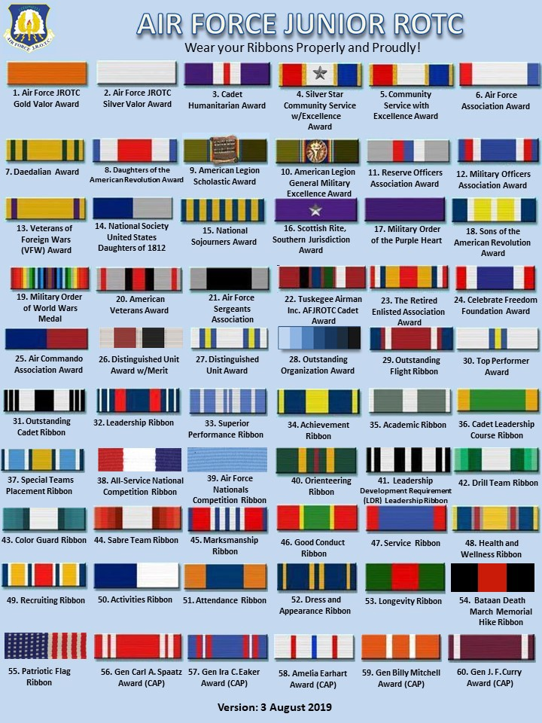

TX-952 Uniform Inspection

- Cadets are required, by the Air Force, to wear the uniform one day per week.

- “Uniform Day” will be on Wednesdays.

- On Uniform Day, cadets will form up in a Uniform Inspection Formation, and their uniforms will be inspected, for a grade, for proper wear and cleanliness.

- Uniform inspection grades are 40% of your JROTC grade. It is extremely important that you understand that failing to wear the uniform could cause you to fail JROTC and be removed from the program.

- This uniform inspection is just like an assignment in any other CHS class. Therefore, if you are absent on uniform day, you still must “complete” the assignment by wearing the uniform and being inspected on the first day you return to school. This inspection, after an absence, is for full credit.

- Not wearing the uniform on uniform day, without being excused by an instructor, is the same as failing to turn in an assignment on time. If you are not in uniform for the weekly uniform inspection, you will receive a grade of zero. The uniform grade counts for 40% of your overall grade.

- The ONLY exceptions are serious illnesses or family emergencies beyond your control keeping you out during the day of the inspection and those days following the inspection day.

- If you have to wear your uniform for an activity such as a color guard or drill meet
will normally fulfill the uniform requirement for that week and you will
not have to wear the uniform on Uniform Day.

Saluting

- Cadets salute when:
  - Reporting, such as at the beginning of class
  - In uniform and outside
- Who salutes whom:
  - Enlisted cadets salute all cadet officers
  - Cadet officers salute officers of higher rank
  - All cadets salute the SASI, when outside or when reporting to his office

American Flag, Pledge of Allegiance and National Anthem
The proper customs associated with honoring the American Flag, reciting the Pledge of Allegiance and showing respect during the playing of our National Anthem change when wearing a US military uniform. They also depend upon whether or not you are in or outdoors. Here are the proper customs:

 | Wearing Civilian Clothes |  | In Uniform
 | Indoors | Outdoors | Indoors | Outdoors
American  Flag | Stand at attention placing your right hand over your heart. | Stand at attention placing your right hand over your heart. If wearing a hat, the hat must be removed and placed over the left shoulder. | Stand at attention only. | Stand at attention and render the proper salute.
Pledge of Allegiance | Stand at attention placing your right hand over your heart. | Stand at attention placing your right hand over your heart. If wearing a hat, the hat must be removed and placed over the left shoulder. | Stand at attention only. | Stand at attention only.
National Anthem | Stand at attention placing your right hand over your heart. | Stand at attention placing your right hand over your heart. If wearing a hat, the hat must be removed and placed over the left shoulder. | Stand at attention only. | Stand at attention and render the proper salute
Chain of Command

The term “chain of command” refers to the line of people above and below an individual through which commands and guidance are passed. In the military, the top of everybody’s chain of command is the President of the United States, who is also America’s “Commander in Chief.” The chain then goes down through people at the levels between the President and the individual. If the individual is responsible for leading or directing others below him/her, the chain continues to the bottom. Below is the chain of command for every Air Force JROTC cadet.

President of the United States, the Honorable ________________________________________

Secretary of Defense, the Honorable _______________________________________________

Secretary of the Air Force, the Honorable ___________________________________________
Air Force Chief of Staff, General __________________________________________________
Commander, Air Education and Training Command, General ____________________________
Commander, Holm Center (ROTC and Officer Training School) Brig Gen __________________
Director, Air Force Junior Reserve Officer Training Corps, Col __________________________

TX-952 Senior Aerospace Science Instructor, ________________________________________

TX-952 Aerospace Science Instructor, ______________________________________________

TX-952 Corps Commander, Cadet Colonel __________________________________________

Deputy for Operations, Cadet ___________________, ________________________________

______ Flight Commander, Cadet _____________,___________________________________

______ Flight Sergeant, Cadet ________________, __________________________________

Element Leader, Cadet ________________, ________________________________________

Warrior Knowledge

“Warrior Knowledge” refers to information about JROTC, the Air Force and the military that cadets should learn after being in JROTC one or two semesters. Uniform inspections provide good opportunities to determine how well cadets are learning this information. Therefore, during uniform inspections cadets may be asked “warrior knowledge” questions. If a cadet knows the answer, he/she will receive 3 bonus points on his/her uniform inspection grade. If a cadet does not know the answer, he/she will NOT lose points. Cadets may be asked questions about the information listed below, as well as specific topics being covered that week in class.

- Mission of AF JROTC - Air Force Core Values
- JROTC and Air Force ranks - Chain of Command
- AF history - Organization of the Cadet Corps - US Flag etiquette - Topics below and in this Handbook

Phonetic Alphabet

A - Alpha | J - Juliett | S - Sierra
B - Bravo | K - Kilo | T - Tango
C - Charlie | L - Lima | U - Uniform
D - Delta | M - Mike | V - Victor
E - Echo | N - November | W - Whiskey
F - Foxtrot | O - Oscar | X - X-ray
G - Golf | P - Papa | Y - Yankee
H - Hotel | Q - Quebec | Z - Zulu
I - India | R - Romeo

Military Time. Military time is based on a “24 hour clock”.

1 am = 0100 hours | 7 am = 0700 hours | 1 pm = 1300 hours | 7 pm = 1900 hours
2 am = 0200 hours | 8 am = 0800 hours | 2 pm = 1400 hours | 8 pm = 2000 hours
3 am = 0300 hours | 9 am = 0900 hours | 3 pm = 1500 hours | 9 pm = 2100 hours
4 am = 0400 hours | 10 am = 1000 hours | 4 pm = 1600 hours | 10 pm = 2200 hours
5 am = 0500 hours | 11 am = 1100 hours | 5 pm = 1700 hours | 11 pm = 2300 hours
6 am = 0600 hours | 12 pm = 1200 hours | 6 pm = 1800 hours | 12 am = 2400 hours

Cadet Organization and Staff Personnel Expectations

The Corps of cadets has a staff, squadrons, flights and elements. Each class is a flight, and each flight has 3 or 4 elements.

Primary Duties for all cadets:

Regardless of title or job position, a cadet’s primary duty is to be the best cadet they can be – all the time. Wearing the uniform every uniform inspection day, coming to school and to class prepared to learn, showing up to help in community services, helping their fellow cadets, living by the Air Force Core Values, and acting like the adults they are becoming.

General Cadet Officer Requirements:

- Impeccable uniform and consistent uniform wear.
- Being in grooming standards, all the time!
- Us tact and diplomacy when dealing with others – always.
- Do your job. Do a great job. Be a leader!

Below are the main cadet positions, jobs, and their duties.

Corps Commander, CC.
The Corps Commander is responsible for everything that happens in the Corps. He/she is the cadet the instructors work with most closely and most often.
- Oversee all Corps activities
- Represent the Corps at functions
- Conducts weekly staff meetings (Must have an agenda.)

Vice Corps Commander, CV.

- Assists the CC in any way necessary.
- Represents the CC when the CC is absent.
- Oversee special Corps projects.
- Attends weekly staff meetings.

Operations Officer, DO.

(Operations concerns “what we do”.)The DO is responsible for:
- Must know how to command a color guard.
- Take care of manning for community services.
- Always request more volunteers than needed. This helps in the event someone fails to show up for an event.
- You need to show up for all community color guards - this is required.
- Do not depend on Lt Col Mackey or MSgt Hardie to find people for an event.
- During football season, select color guards for the pep rallies and for the march-on.
- Attend weekly staff meetings.
- Update the drill meet manning spreadsheet weeks prior to our drill meet in April.

Physical Training Officer:

- This is not the same as the Physical Training Team Commander – could be but not necessary.
- Come up with exercises all flights are to do each week.
- Research and prepare a monthly wellness briefing. You can find all sorts of information for the briefing on the internet. Check out You Tube videos as well.
- Assist in keeping records in Wings updated with the Presidential Physical Fitness test results.
- Keep spreadsheets up to date with the information pertaining to the unit’s PT goal.
- Come up with creative ways to motivate the cadets to do better in fitness.
- Attend weekly staff meetings.

Logistics Officer, LG.

- Receive items back from cadets leaving JROTC.
- Receive items from EMALL.
- Keep logistics straightened up and cleaned up.
- Conduct inventories with the Aerospace Science Instructor (ASI)/Military Property Custodian (MPC).
- Check levels on ribbons. Let the ASI/MPC know if ribbons need to be ordered.
- Perform as the Support Team Commander.
- Select Support Team Members.
- Provide the ASI/MPC with a list of items needed for any up-and-coming drill meets. Do this at least one week in advance.
- Update Wings when items have been received and issued to cadets as well as those turned-in.
- Attend weekly staff meetings.
Logistics Cadet/NCOs and Cadet/Airmen: Assist the Logistics Officer.

Personnel Officer, DP.

- Keep Wings updated to show completed events such as:
- - Community Service
- - Co-curricular events
- - Curriculum in action trips
- - Drill meet competitions
- - Awards
- - Promotions
- - Anything else the ASI requires for cadet record upkeep

Public Affairs Officer, PA.

Public Affairs is responsible for putting the JROTC’s story out to the public/campus.
- Keep the hallway bulletin board up-to-date with current pictures.
- Take photos at events. If you can’t make it to an event, make sure you have a substitute – this is your responsibility.
- Write articles for the school paper and local newspaper. Get photos to Mrs. Vandiver so cadet photos can be seen on the large monitors in the Commons and on the large monitor in the front office. Many visitors come through that office every day.
- Make a scrapbook for the current school year, showing cadet activities and accomplishments – this is the unit’s history.
- Attend weekly staff meetings.

Corps Chaplain:

- You are NOT expected to be perfect, but your behavior should be above reproach.
- You will be expected to offer prayers at ceremonies and if you are on a drill team, prior to leaving for a drill meet.
- A weekly Bible lesson is suggested – you must be prepared and consistent.
- Arrange for monthly chaplain’s movie night.
- Attend weekly staff meetings.

Resource Officer, RA:
- You must have someone with you when money is being counted. This is a normal procedure for the accounting of funds. It is a safeguard reducing the impression of impropriety.
- Prepare cash collection forms indicating who the money was collect from and for what purpose.
- Count all funds listing them on a cash tally sheet. Again you must have another cadet with you when counting or receiving money.
- Once per quarter, help reconcile the JROTC funds spreadsheets with those of the school’s bookkeeper.
- Don’t wait for the ASI to tell you there is money to be counted – ask! Be proactive.
- Attend weekly staff meetings.

Recruiting/Retention Officer:
- Schedules visits to the middle school and high school
- Make sure paperwork is ready for each event
- Keep a record of students talked to. This will be a roster with the student’s name and phone number
- Create promotional materials

Flight Commanders: Direct and command the flight on a daily basis. Because of the daily responsibilities, and because the Flight Commander is directly involved in management of the classroom, this is one of the most important positions in the Corps. You act for the instructor when directed to do so. You have no authority to discipline any of your flight’s members. You may recommend disciplinary action only.

Flight Sergeants:

- Assist the flight Commander and perform Flight commander’s duties when the commander is absent or unavailable.
- Position yourself in front of the flight during uniform inspections.

Element Leaders:

- Make initial report at the start of class.
- During uniform inspection, have the cadets in your element form up and align themselves.
- Lead the element during inspections and drill.
- Inspect your element during inspections with the flight commander.

Military Drill (Marching)

All cadets must learn to march and to perform basic drill movements.

The basic drill movements that cadets must learn are:

- Parade Rest - Halt
- Attention - Fall In
- Present Arms - Dress Right Dress
- Order Arms - Ready Front
- Right Face - Open Ranks March
- Left Face - Close Ranks March
- About Face - Fall Out
- Forward March

Other movements that are performed in flight and element formation while marching are:

- Right Flank - Eyes Right
- Left Flank - Ready Front
- Column Right - Change Step
- Column Left - Right Step
- To the Rear - Left Step

Drill Terms:

Alignment – Dress or Cover

Cadence – the uniform step and rhythm in marching that is the number of steps marched per minute. We march at quick time which is 100 to 120 steps per minute.

Cover – individuals aligning themselves directly behind the person in front of them

Distance – the space between individuals in formation (approximately 40”) as measured from their chest to the back of the individual in front of them

Double Time – the rate of marching 180 steps per minute

Dress – alignment of elements side by side or in line maintaining proper interval

Element – the basic formation, the smallest drill unit comprised of at least 3 individuals

Flight – at least two, but not more than four, elements

Guide – the individual designated to regulate the direction and rate of march

In Column – the arrangement of elements side by side with the guide and element leaders at the head

In Line – the arrangement of elements one behind the other with the guide and element leaders to the far right
Interval – the space between individuals placed side by side (Normally one arm.)

Mark Time – marching in place at a rate of 100 to 120 steps per minute

Quick Time – the rate of marching at 100 to 120 steps per minute

Slow Time – the rate of marching at 60 steps per minute (used in funeral ceremonies)

Rest Positions – parade rest, at ease, rest, fall out

Drill Commands – an oral order; most have two parts, preparatory command and command of execution

Preparatory Command – explains what the movement will be and mentally prepares the cadet to execute the movement – this is not to be rushed

Command of Execution – follows the preparatory command and explains when the movement will be carried out

Combined Command – drill commands in which the preparatory command and the command of execution are combined (fall in, at ease, rest)

Supplementary command – given when one unit of the element must execute a movement different from the other unit or must execute the same movement at a different time (stand fast)
Informational Command – no Preparatory Command or Command of Execution. (Prepare for inspection.)

General Rules for Commands

- Give commands from the position of attention.
- While marching, the leader must be in step therefore keeping the flight in step.
- The leader should be positioned toward the back of the flight – not behind the flight – but toward the back. This allows their voice to carry across the flight.
- When not facing the flight, give commands over the right shoulder. This should not happen, if it does, it should be rare and not common.
- Revoke a preparatory command (correct a mistake) by saying “As you were”. This must be accomplished prior to giving the command of execution.

Characteristics of a Command Voice

- Loudness – Volume used in giving commands.
- Projection – The ability of the voice to reach whatever distance desired without strain.
- Distinctness – The correct use of the tongue, lips, and teeth to form the separate sounds of a word. (So commands are clear.)
- Inflection – The change in pitch of the voice. (With inflection commands are not monotone.)
- Snap – That extra quality in a command that demands immediate response. (Crispness or sharpness.)

Parental Permission for Cadet Trips

Some JROTC activities involve trips off campus. These include one-day trips to drill competitions at other schools or to museums or other facilities to complement Aerospace Science courses, and, usually once per year, an over-night trip to an aviation-related event or facility. No cadet may go on any of these trips without written permission (a permission slip) from his or her parent or guardian. Our policy is, “No slip, no trip.” The permission slip must be turned in no later than one day prior to the trip – not the day of the trip. You MUST be responsible and get your permission slip in on time. If your parents work at night and you won’t see them until the next morning, leave the permission slip out where you know they will see it. Attach a note expressing the urgency of getting the permission slip back on time. TAKE THE INITIATIVE!!

Remember, no slip, no trip!!!

TX-952 Promotion Policies

Senior cadets involvement in promotions:

Cadet officers, normally third and fourth year cadets, along with C/CMSgt’s will be allowed to suggest whether an individual should be promoted or not. This will be based strictly on their observations of that individual’s performance and behavior. The cadet officers will be allowed to proctor the promotion test and will be responsible for drill evaluations associated with promotions.

General. A cadet’s rank is based on time in the JROTC, performance and behavior as a cadet, participation in JROTC activities, completion of additional training, and the job the cadet is assigned.

Starting rank. All new cadets start at the first enlisted rank, E-1, Cadet Airman Basic. After completing the Summer Orientation Program or after the first 6 weeks, new cadets take a promotion test and, if they pass, are promoted to E-2, Cadet Airman.

The basic rank schedule. Here are the ranks associated with the 4 high school grades.
- 9th grade year – airman ranks
  - AB, Amn, A1C, SrA.
- 10th grade year – sergeant (Non-Commissioned Officer (NCO)) ranks
  - SSgt and TSgt (Unless you completed a CLC and was promoted to SSgt, then you may make it to MSgt)
- 11th grade year – company grade officer ranks (Temporary 2nd and 1st Lt’s and captain.)
  - MSgt and SMSgt (Senior Enlisted.)
- 12th grade year – Officer Ranks (Must have a corps position.)

Promotion schedules.
- First year cadets: After their first promotion to Airman (during the Summer Orientation or after the first 6 weeks), cadets can be promoted in January to Airman First Class and then have until May to make Senior Airman. (There are exceptions we will discuss.)
- Upper class cadets: Cadets are eligible for promotion at the start of each semester.

Promotion requirements. If a cadet is eligible for promotion, these requirements must be met:
- Passing: A cadet must have had a “B” or better in JROTC the previous semester.
- Any money owed to JROTC must be paid.
- Promotion test (Required for SSgt through SMSgt)
- Participation Points: (January, upperclassmen promotion only.) A cadet must have participated in enough activities in the Fall to have accumulated 50 points.

Other promotion opportunities for enlisted ranks:
- Promotion for football games. If a first-year cadet attends at least 4 home football games, he/she will be promoted one rank in November – to Airman First class.
- Cadet Leadership Course. After completing CLC, a cadet will skip a rank and be promoted to the next rank at the start of the fall semester. (For most, this would be Staff Sergeant.)

Officer ranks. To be promoted to an officer, a cadet must be at least a junior and have completed CLC, or be a senior with enough experience. In all cases, cadets must have shown that they have the maturity needed for a leadership position – no corps position, job, no officer ranks.

Exceptions. For various reasons, some cadets achieve ranks at different times.
- Students who join ROTC as juniors or seniors may be promoted more rapidly if they learn cadet responsibilities quickly and demonstrate appropriate maturity.
- Cadets chosen for jobs which require higher rank may skip one or more ranks to assume the new rank. These promotions will normally be temporary.

Promotion Tests

Airman Promotion Test covers the following:

- The Mission of JROTC
- Cadet Honor Code
- Air Force Core Values and TX-952 Corps Values
- All ranks and their insignias.
- How to put rank insignia on the uniform shirt, jacket and coat.
- Perform approximately 4 to 6 basic drill movements.

Senior Airman Promotion test: March a flight or element (give the commands) through a sequence of 20 drill commands. You must memorize the list.
Drill Evaluation Sequence for Promotion to Senior Airman
(The flight will have already fallen-in prior to the start of the evaluation.)

You will be scored on the following:
- Command Voice
- Timing (Timing between the preparatory and command of execution)
- Calling commands on correct foot
- Your marching (Not how well the flight performs.)
- Confidence
- Finishing routine where you started (Approximately the same spot.)

List of commands
- Present Arms 11. Column Right March (R)
- Report in to the Evaluator 12. Forward March (L)
- Order Arms 13. Change Step March (R)
- Parade Rest 14. Column Right March (R)
- Flight Attention 15. Forward March (L)
- Left Face 16. Column Right March (R)
- About Face 17. Forward March (L)
- Forward March 18. Flight Halt (L)
- Column Right March (R) 19. Left Face
- Forward March (L) 20. Report Out

Notes:
- “L” and “R” refer to the foot on which the command is given.

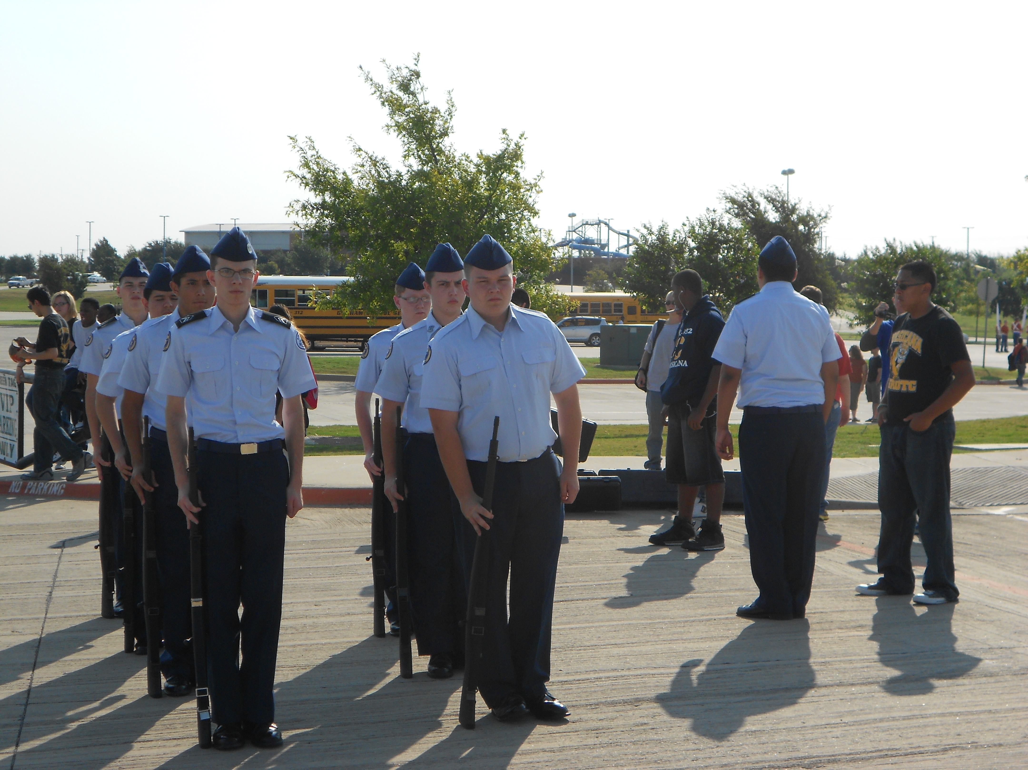
Promotion to NCO ranks (Staff Sergeant through Chief Master Sergeant):

- Written test:
  - A 100-question (multiple-choice and matching) test covering Air Force, Junior ROTC and TX-952 information.
  - The number required to pass increases with each higher rank.

- Marching test (SSgt, TSgt and MSgt). March a flight (give the commands) through the following command sequence:

- Fall In 16. To the rear march (R)
- Open rank march 17. To the rear march (R)
3. Ready front 18. Column right march (R)
4. Close ranks march 19. Forward march (L)
5. Present arms 20. Eyes right (R)
- Order arms 21. Ready front (L)
- Parade rest 22. Column right march (R)
- Attention 23. Forward march (L)
- Left face 24. Change step march (R)
- About face 25. Column right march (R)
- Forward march 26. Forward march (L)
- Right flank march (R) 27. Flight halt (L or R)
- Left flank march (L) 28. Left face
- Column right march (R) 29. Right step march
- Forward march (L) 30. Flight halt (when feet are together)

Notes:
- “L” and “R” refer to the foot on which the command is given.
- You must memorize the commands; you may not use the command list.

Promotion to Cadet SSgt, TSgt, MSgt, SMSgt and CMSgt.

September promotion cycle: To be eligible, must not owe money to corps.

The drill evaluation will always be worth 31 max points if all 31 commands are called correctly including reporting in and reporting out. The first command of “fall-in” will not be part of the evaluation. A cadet may earn up to a max of 100 promotion points from the promotion test – one point for every correct answer.

For C/SSgt, a cadet must have a total of 60 promotion points between their drill evaluation and promotion test. (15 points of the 60 must be from drill and 45 from the test.)

For C/TSgt, a cadet must have a total of 70 promotion points between their drill evaluation and promotion test. (20 points of the 70 must be from drill and 50 from the test.)

For C/MSgt, a cadet must have a total of 100 promotion points between their drill evaluation and promotion test. (30 points of the 100 must be from drill and 70 from the test.)

For C/SMSgt, a cadet will take the promotion test only and must earn at least 90 points to be promoted. Must score a perfect 31 on the drill portion.

For C/CMSgt, a cadet must score a 95 or higher on the promotion test and be involved in corps activities. Must score a perfect 31 on the drill portion. A C/CMSgt is to be “The” example to all other enlisted cadets. Cadets with this rank will be held to a higher standard. Must be recommended by the cadet staff.

February promotion cycle: To be eligible, must not owe money to corps, be passing AFJROTC, and have earned 50 participation points since August of the current school year.

For C/SSgt, a cadet must have a total of 60 promotion points between their drill evaluation and promotion test. (15 points of the 60 must be from drill and 45 from the test.)

For C/TSgt, a cadet must have a total of 70 promotion points between their drill evaluation and promotion test. (20 points of the 70 must be from drill and 50 from the test.)

For C/MSgt, a cadet must have a total of 100 promotion points between their drill evaluation and promotion test. (30 points of the 100 must be from drill and 70 from the test.)

For C/SMSgt, a cadet will take the promotion test only and must earn at least 90 points to be promoted. Must score a perfect 31 on the drill portion.

For C/CMSgt, a cadet must score a 95 or higher on the promotion test and be involved in corps activities and score a perfect 31 on the drill portion. A C/CMSgt is to be “The” example to all other enlisted cadets. Cadets with this rank will be held to a higher standard. Must be recommended by the cadet staff.

NOTE: Even though you only have to earn a minimum of points from the drill evaluation, 15 for C/SSgt for example, your goal should be to get them all, 31 points. We say this to encourage you to do your absolute best, and not just “enough” to get by.
(NEW) How to maintain your rank:

Yes, rank is earned but it can be taken away just as easy. You will have no fear in being demoted, reduced in rank, as long as your behavior and performance meets acceptable standards. For example, you stay in grooming standards and behave properly in JROTC and outside JROTC – your other classes and outside of school. Also, and this is serious, the more rank an individual makes they are expected to be involved in community service. Ask yourself, “Why should I be allowed to wear sergeant or officer ranks if I’m not going to be involved in community service?”. The answer is simple, you shouldn’t. You are to be an example – a positive one.

Promotion, Letter Jacket and Honor Stole Points

In JROTC, we reward cadets for their effort, performance and accomplishments in several ways. In addition to ribbons, promotions and more responsible duties and positions, cadets also can earn a Corsicana High School Letter Jacket, and, to show achievement, involvement and excellent performance over years of JROTC service, we also have Honor Stoles for graduating seniors.

To measure accomplishments and contributions to the Corps, we award points for cadets’ participation in activities and for individual accomplishments. In addition to earning points for promotion in January, a cadet accumulates points from semester to semester and year to year.

Promotions: A cadet must acquire enough points during the Fall semester to be promoted in January. The number of points needed depends on one’s rank, and is specified on the Promotion and Letter Jacket form. Promotion points do not accumulate from semester to semester.

Letter Jackets: As with athletic teams or other organizations and activities that students devote time to outside of regular school hours, if a cadet does more in JROTC than just come to class, he/she may be able to earn a letter jacket. Generally, it takes a very active cadet about one and a half years, normally by December of their second year in JROTC, to accumulate enough points for a jacket.

Honor Stoles: These are worn over the graduation gown and signify a high-level of involvement in JROTC. Only very active cadets earn enough points for the Honor Stole – 1000 points for the basic stole and 1200 for the stole with honor.

More detailed information on earning the letter jacket and honor stole:

Honor Stole Requirements for JROTC
- Must be in JROTC their entire senior year and have been in JROTC at least three of their four high school years
- To be considered, they must have 1000 service points (1200 or more and you get the word HONOR embroidered on the stole.)
- Must have a 95% or above in JROTC their second semester of their senior year and must have a 80% overall in all other classes
- No missing uniform inspection grades their senior year and must stay in Air Force grooming standards – all the time
- No disciplinary problems their entire senior year, in class or out, and no major disciplinary problems all other years
To Earn the Letter Jacket
- Must earn 500 service points to be considered for the jacket
- Must maintain a grade of 85% or above in JROTC (You have to wear the uniform to have this kind of grade.)
- The jacket will not be presented prior to their second semester of their second year regardless of the points earned.
- Must remain in JROTC for a third year – otherwise, the jacket will not be purchased/or taken back from the cadet. Why award someone who does not plan on staying with JROTC?

Losing Points:
“Going backwards”! It also is possible to lose points. A cadet will lose points for a zero uniform inspection, ISS, or other CHS disciplinary actions. For example, a zero on a uniform inspection costs 5 points and an ISS costs 10 points. So, a cadet can do many good things and then lose much of the benefit because of too many bad things.

Here are some (not all) of the activities and their point values that we keep track of:

Activity / Accomplishment Points Awarded

Football game march-on 10
Highway clean-up 10
Short community service project 10
Long community service project 30
Marching in a parade 25
Meeting a fund-raising goal 10 or more
Making an academic honor roll 40 or more
Being on a drill team, and competing up to 75
Performing a color guard 10
Being an element leader, flight sergeant, 15, 30 and 50,
or flight commander respectively
Satisfactorily fulfilling staff position duties 30 or more
Graduating from Summer Leadership School 50

The Tiger Order of the Sword

This is the most prestigious local awarded to a cadet here at Corsicana High School. It is awarded to a deserving senior cadet. This cadet has given four years of their high school career to AFJROTC. The following is what helps determine the recipient:

- Must have consistently lived by the Air Force Core Values of Integrity First, Service Before Self, and Excellence in all we do.
- Must be involved in both community service and co-curricular activities including drill teams.
- Must have demonstrated leadership by training others – helping to prepare future leaders.
- Being a good example.

TX-952 Corps Discipline System

Introduction: Note: The Air Force fully expects students enrolled in AFJROTC will abide by both the school’s and Air Force policies and standards. It is never one or the other – it’s both. One important way in which AFJROTC is different from most other courses at Corsicana HS is that we’re a team. Cadets do many things together. Thus, your behavior as a cadet affects and reflects not only on you, but also on the entire Corps of Cadets, and even the Air Force. Students should behave properly in all classes, but in AFJROTC we hold you to a higher standard of behavior for the sake of the entire program. The Corps Discipline System is designed to reinforce proper cadet behavior by rewarding good behavior and applying penalties for behavior that does not meet Corps standards.

The Corps Discipline System is separate from the Corsicana High School discipline program, but there is a connection. If a cadet breaks a Corps rule that is not a CHS student rule, it is dealt with in the Corps only, and there is no additional CHS punishment. However, if a cadet breaks a serious CHS rule, there probably will be one or more Corps penalties in addition to the punishment the student receives from CHS administrators. For example, an offense that results in an ISS or CHS suspension will have consequences in the Corps, too.

In our Corps Discipline System, “punishment” basically means delay or loss of the rewards that you would earn by behaving as a cadet should. Good behavior and performance that contribute to flight and the Corps, not only result in a good grade in AFJROTC, but also leads to more responsibility, more opportunities, more privileges and often faster promotions in rank. On the other hand, behavior that causes problems for the flight or Corps often will delay these things, and, if serious enough, can result in the cadet losing things he/she already has, such as losing privileges or even being demoted (reduced in rank).

Improper behavior or lack of cooperation, depending upon how serious or frequent, can lead to:
- verbal correction;
- Corps Detention - is like CHS D-hall, except it is served in the Corps area. During
Corps Detention the cadet will be given chores or Corps tasks to do. For example, picking of trash around campus.

Zero Uniform Inspection grade (“ZUI”):
- loss of 5 letter jacket points
- 2 ZUIs for a first-year cadet or 1 ZUI for an upperclassmen cadet will make a cadet ineligible to compete at the next drill meet.
- ZUIs will be used to determine who goes on a trip (No uniform, no trip!)

CHS ISS:
- loss of 10 letter jacket points
- a second ISS or the first one for anything other than a dress-code violation will make a cadet ineligible for the next drill team competition or color guard event
- ISSs also are used to determine who goes on a trip

CHS Suspension, DAEP, Honor Code Violation or behaviors such as repeated challenges to a higher-ranking cadet’s authority, disrespectful behavior toward an instructor an another teacher, act of sexual harassment, fighting, or anything that brings discredit on the Corps or CHS, because there are very serious, are handled on a case-by-case basis. Usually they involve one or more of the following:
- loss of 25 letter jacket points for suspension, 50 points for DAEP;
- removal from drill team or staff or command position in the Corps;
- demotion (reduction in rank):

Senior Staff Input: To decide what punishments are appropriate for serious or repeated problems, such as those listed above, or even for multiple ISSs or ZUIs, senior staff members may be asked for their input on actions that should be taken against an fellow cadet. These suggestion will be made to the instructors who have the sole responsibility for taking corrective/disciplinary actions. .

CHS Referral: We try to take care of AFJROTC discipline problems in the Corps. However, if a cadet commits a serious CHS infraction, AFJROTC instructors, as must all other teachers, will send the cadet to the office or report the infraction on a Referral form.
NOTE: Even though you only have to earn a minimum of points from the drill evaluation, 15 for C/SSgt for example, your goal should be to get them all, 31 points. We say this to encourage you to do your absolute best, and not just “enough” to get by.

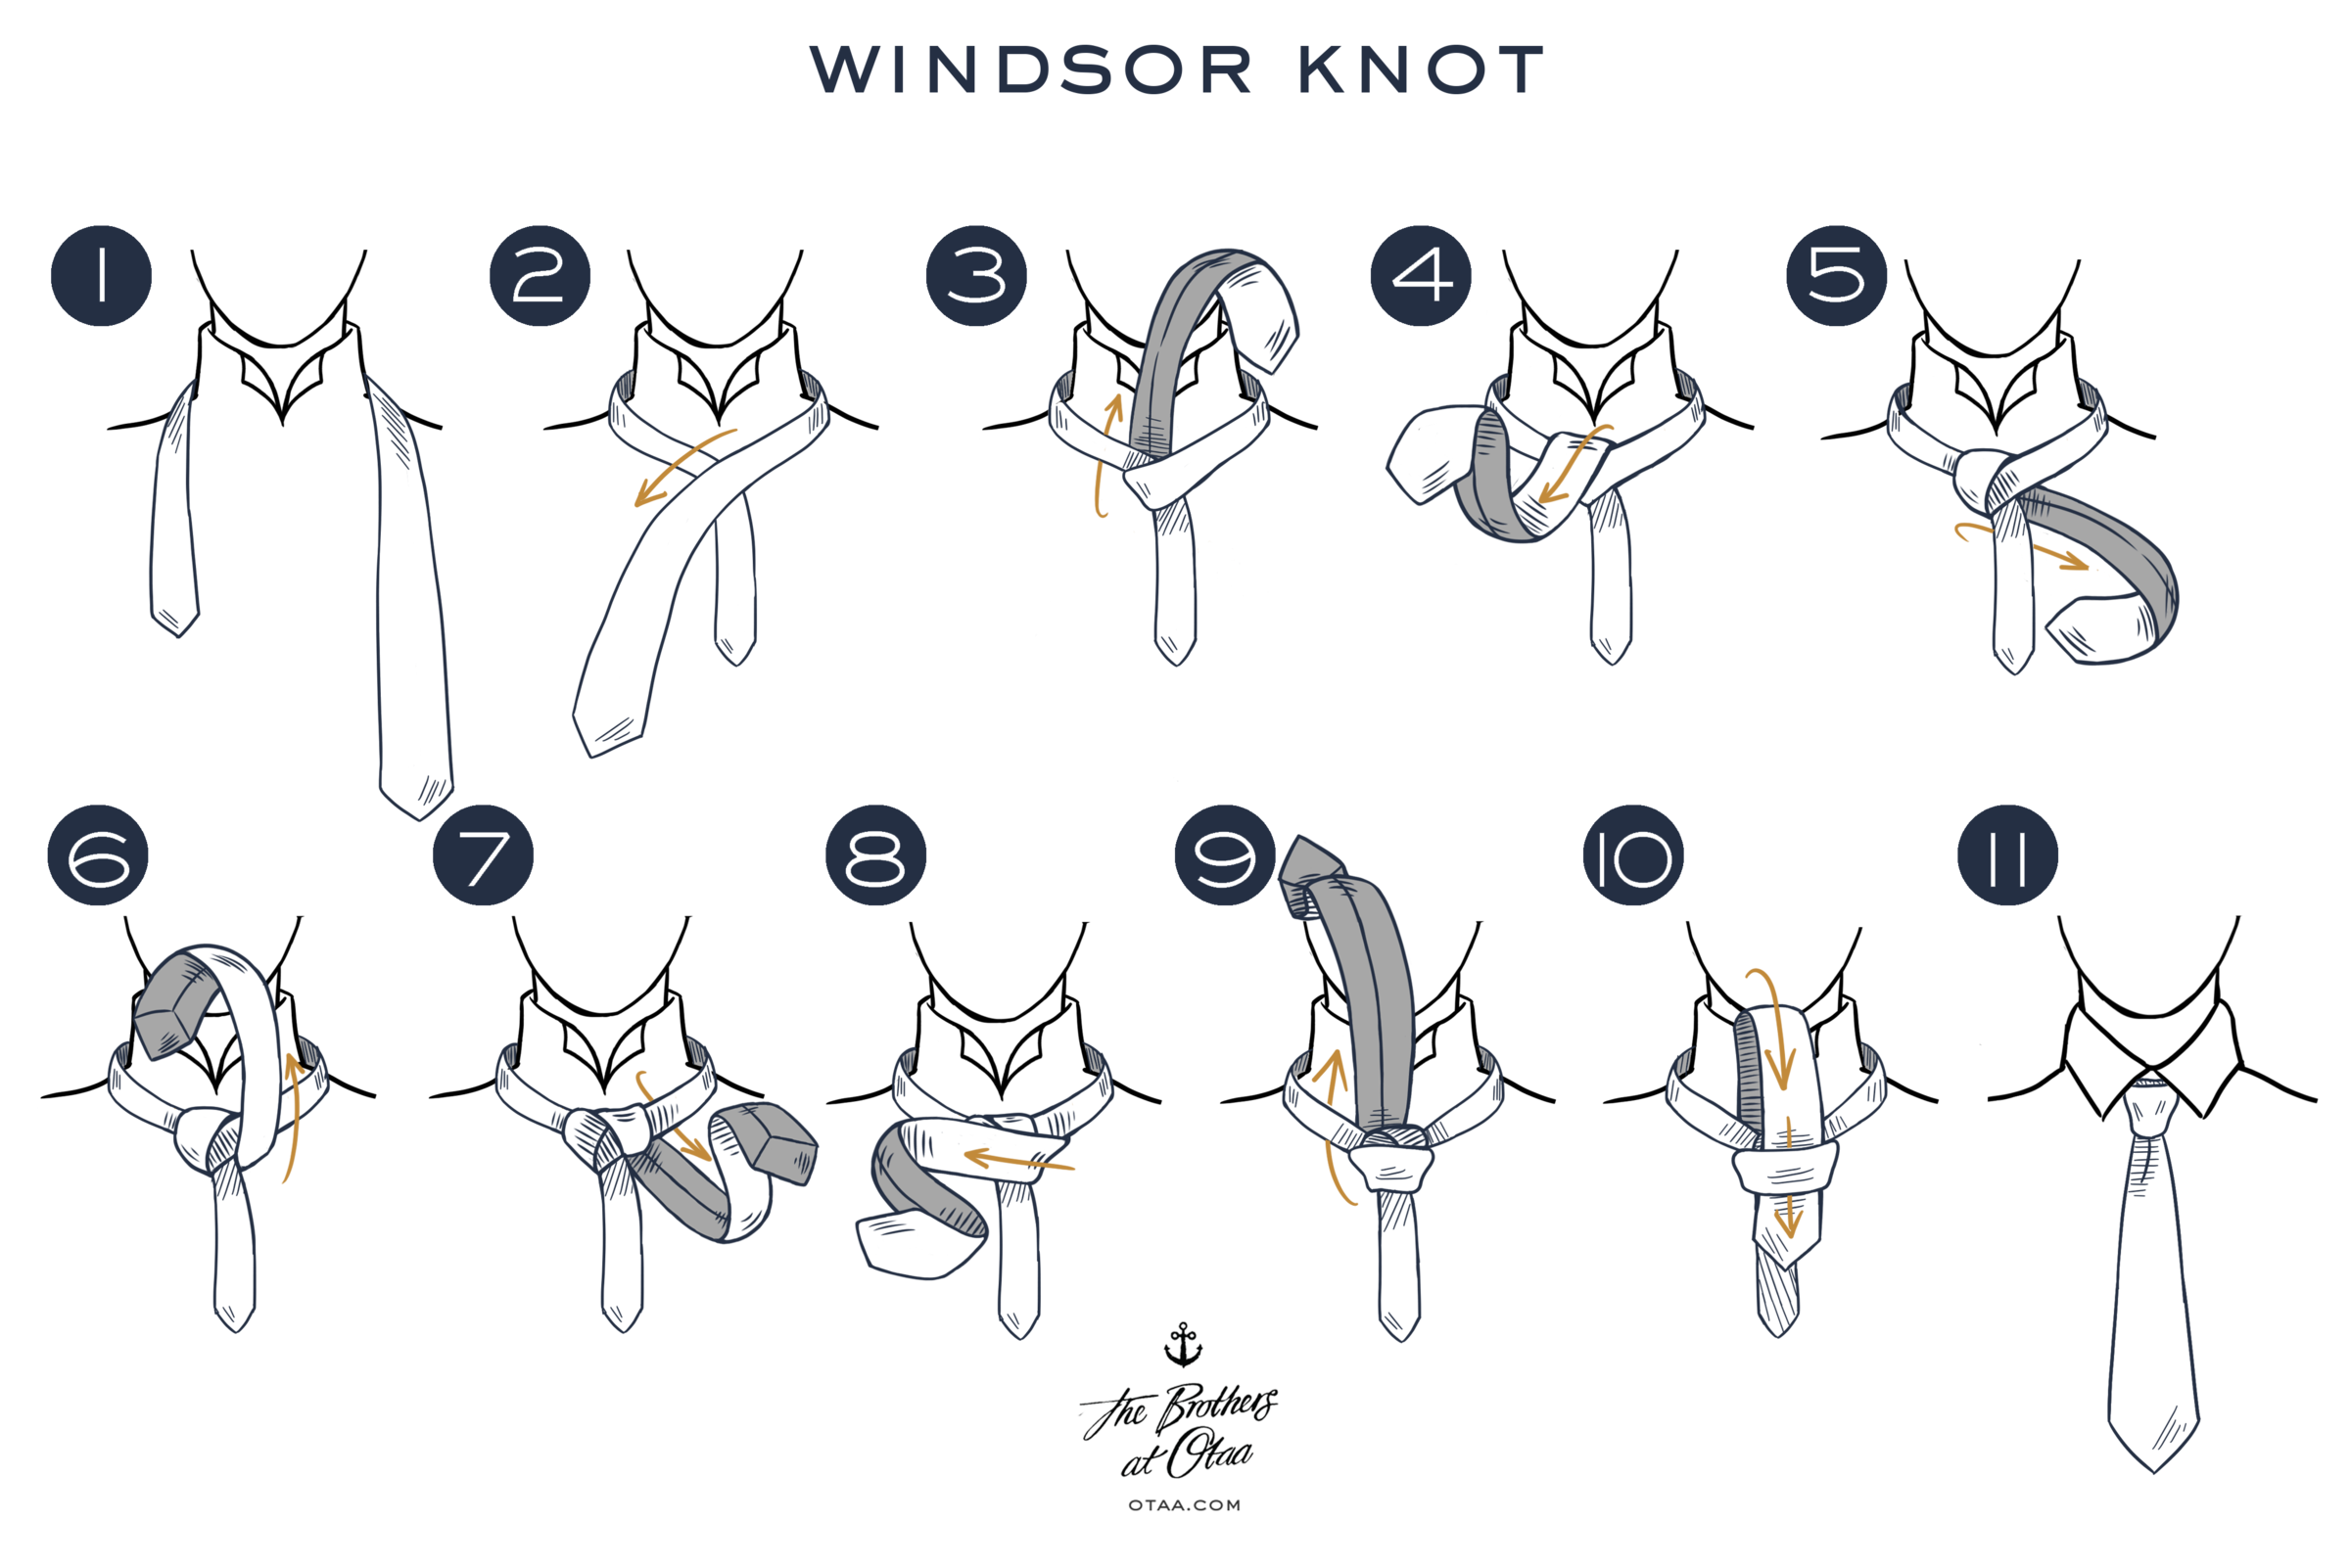

CORSICANA INDEPENDENT SCHOOL DISTRICT

NONDISCRIMINATION STATEMENT

With respect to students:
Corsicana ISD (CISD) does not discriminate on the basis of race, color, religion, national origin, gender, or disability in providing education services, activities, and programs, including vocational programs, in accordance with Title VI of the Civil Rights Act of 1964, as amended; Title IX of the Educational Amendments of 1972; and Section 504 of the Rehabilitation Act of 1973, as amended.
Questions or concerns about discrimination against students based on sex, including sexual harassment should be directed to the CISD Director of Human Resources, the district Title IX coordinator. Questions or concerns about discrimination on the basis of a disability should be directed to the CISD Transition Coordinator, the district ADA/Section 504 coordinator. All other questions or concerns relating to discrimination based on any other reasons should be directed to the Superintendent at the Lee Education Center 2200 W. 4th Ave Corsicana, TX 75110, phone (903) 874-7441.

Con respecto a los estudiantes:
Corsicana ISD (CISD) no discrimina por motivos de raza, color, religión, origen nacional, sexo o discapacidad en la prestación de servicios educativos, actividades y programas, incluyendo programas vocacionales, de acuerdo con el Título VI de la Ley de Derechos Civiles de 1964, en su versión modificada; Título IX de las Enmiendas Educativas de 1972; y la Sección 504 de la Ley de Rehabilitación de 1973, según enmendada.
Las preguntas o inquietudes sobre la discriminación contra los estudiantes por motivos de sexo, incluido el acoso sexual deben ser dirigidas al Director CISD de Recursos Humanos, el distrito coordinador del Título IX. Preguntas o dudas acerca de la discriminación por motivos de discapacidad deben ser dirigidas a la Coordinadora CISD Transición, la ADA barrio / coordinador de la Sección 504. Todas las otras preguntas o inquietudes relacionadas con la discriminación basada en otros motivos deben dirigirse al Superintendente en el Centro de Educación Lee 2200 W. 4th Ave Corsicana, TX 75110, teléfono (903) 874-7441.

